ESD PILOT PROJECT FOR PRIMARY SCHOOLS BY KENYA INSTITUTE OF CURRICULUM DEVELOPMENT
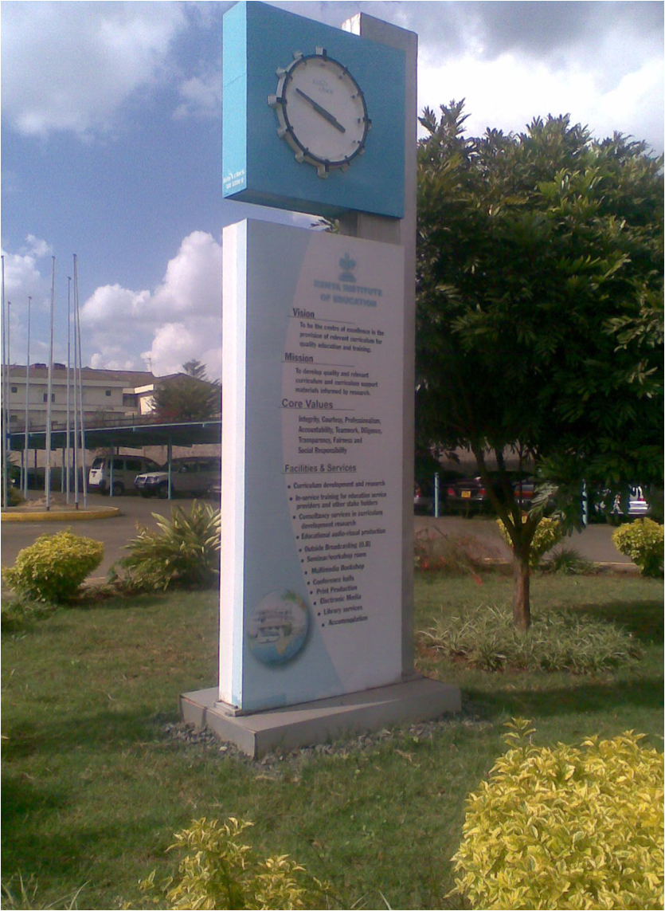
KENYA INSTITUTE OF CURRICULUM DEVELOPMENT
REPORT ON THE PARTNERSHIP EDUCATION FOR SUSTAINABLE DEVELOPMENT PROJECT BETWEEN KENYA INSTITUTE OF CURRICULUM DEVELOPMENT AND SCHOOLS (CITY PRIMARY AND JAMHURI HIGH SCHOOL)
JULY 2014

2.0INTRODUCTION
As Kenya undertakes the various steps to attain the Vision 2030, various stakeholders must put in place strategies that will enable them to make their contribution to this achievement based on their mandate. Within the social pillar, education plays a central role in determining the direction a country takes with regards to growth and development. More importantly, curriculum is crucial as it determines the extent to which learners can contribute to the achievement of the set out goals based on the ability, knowledge, skills and values acquired.
Education is recognized as a process by which human beings and societies can achieve their fullest potential. The design of relevant programmes requires dynamism and incorporation of different and new ideas as need arises. Both formal and informal education is indispensable to changing people’s attitudes. Education is also instrumental in achieving environmental and ethical awareness, skills, values and attitudes that influence positive behavior consistent with enhancing effective participation in decision making.
Kenya Institute of Curriculum Development (KICD) formerly Kenya Institute of Education (KIE) sent officers to Israel in 2010 for training on Education for Sustainable Development (ESD). The Institute sought a partnership with neighboring schools City Primary and Jamhuri High School to foster the understanding of the concept of ESD. In May 2012, an awareness creation meeting was held that brought on board teachers from the selected schools and several other schools within Nairobi.

The Institute also sought the partnership of National Environment Management Authority (NEMA) as a stakeholder which assisted in providing some of the apparatus and equipment the schools needed for the project. Since 2012 various activities have been undertaken by the schools such as establishing tree nurseries, the ecological gardens, management of waste and preparation of compost through various clubs.

2.1 Aim
The aim of the project is to expose the pupils and teachers to the concept of sustainable development and how it can be integrated in school education by engaging learners in outdoor and practical learning sessions where they can apply the concepts learnt in various subjects in real life situations.

2.2 Baseline Survey
A baseline survey was carried out to find out the status of the school and the activities that were being undertaken to facilitate enhancement and or start up of the pilot project activities.
City Primary School
A proposal was developed for the then Kenya Institute of Education to engage with City Primary School and presented to the Senior Management of the Institute. In January 2012 a meeting was scheduled to sensitize the teachers on the intentions of the Institute. During the meeting it was emphasized that the project would be undertaken with the school as a whole community. These include the pupils, teachers, parents as well as the support staff. The key component that would lead to the success of this project is participation by all. The school was found ideal because of its proximity and it has both regular learners and learners with special needs specifically Mentally Handicapped learners and learners with Autistic tendencies.

Based on a consultative meeting, the following suggestions were made:
- The teachers and pupils be allowed to visit KIE to view resources that may be educative to them. Where possible, materials developed by KIE should be brought to the school for viewing by teachers and learners
- Learning resources will be developed from used materials in conjunction with the learners to enable them practice their skills and discover their talents
- Various club and society activities will be revived to give all learners a chance to participate in at least one activity every week
- The learners will be engaged in sourcing for raw materials that will be used to develop the learning items
The following activities were being undertaken in the school at the time the survey was undertaken

- Farming
- The school grew a number of crops including; kales, spinach, groundnuts, cowpeas, barnia among others. To establish a new crop they would purchase seedlings from vendors or use splits from the existing crop (kales).
- There was also agro forestry practiced with different species of trees planted. It was however, noted that some of the species were not friendly to inter-cropping. Additionally the trees were planted close together posing a spacing challenge.
- There were no water conservation measures in place e.g. Mulching. Roof water harvesting was not adequately done in the school. Most of the water goes to waste though the school had fixed gutters.
The school depended on the rains to grow crops with minimal watering using cans. The crop harvested is mainly sold to teachers and the special unit of the school. The garden is being run by pupils of the Environment club with membership of about 35- 40 pupils and the special unit pupils.
Recommendations
- Establish a nursery to raise seedlings to enable pupils learn how seedlings are produced
- Employ drip irrigation to save water and ensure crop production throughout the year
- Enhance water harvesting since most of the rain water is not directed to any collection point.
- Plant high value crops with ready market in the area
- Establish a tree and flower nursery

Sustainability Indicators
- Nurseries established for various crops, trees and flowers
- Drip irrigation in place
- Roof water harvested and stored
- Number of high value crops planted
- Records of income generated from crop sales

- Waste Management
Types of waste generated in the school include; waste papers, polythene bags, plastic bottles and cartons. The disposal method is by open burning in the school compound. No segregation, no waste receptacle and no waste pits. In the school the art club uses some of the waste materials for art work to make articles which are sold to hospitals like Kenyatta Referral Hospital and Gertrude Children’s’ Hospital.
Recommendations
- Have a set of 3 waste collection receptacles to encourage segregation of waste at source
- Promote the 3R (Reuse ,Reduce, Recycle) principals in waste management
- Promote compost making for use in farming
- Promote use of some of the waste to make learning materials
Sustainability Indicators
- Waste segregation receptacles in place
- Quantities of waste generated
- Quantities of materials recovered from waste
- Quantities of compost manure generated
- Number of learning materials made from waste

Jamhuri High School
- Waste management
Types of waste generated in the school include; waste papers, polythene bags, plastic bottles, plates and organic materials. There are no waste receptacles in the school, no segregation and disposal is by burning.

Recommendations
• Have a set of 3 waste collection receptacles to encourage segregation of waste at source
• Promote the 3R (Reuse, Reduce, Recycle) principals in waste management
• Promote compost making for use in farming
Sustainability indicators
- Waste segregation receptacles in place
- Quantities of materials recovered from waste
- Quantities of compost manure generated

- Project for Agriculture class
Every year the students taking Agriculture are given a crop to grow as part of their exam which is rain dependent. The previous year, the examination class did a project on beans growing even though the school has adequate land to establish small scale farming under a club. The school also plans to establish a dairy unit soon. The department of fisheries is establishing a fish pond in the school under the stimulus programme in the vision 2030.
Recommendations
- Employ drip irrigation to save water and ensure crop production throughout the year
- Encourage composting of the bio degradable waste
- Promote commercial farming
- Promote Bio-gas production when the dairy unit is established
- Promote fish farming when the pond is completed
Sustainability indicators
- Drip irrigation in place
- Composting being done
- Income generated from farming
- Bio gas production in place
- Fish pond operational
- Quantities of fish produced in specific time

3.0 Objectives
The programme set the following objectives, to:
- Develop in teachers a self-identity and values reflecting the world view of the teacher as an educator for sustainability;
- Impart knowledge and information on the current environmental, social and economic issues and the relationship between them;
- Build in the learners the value of responsibility through enhanced experiential learning
- Enhance the development of life skills through exposure to creative, participatory and flexible methods of teaching
- Enhance understanding and practice of interactive approaches to teaching
- Provide learners with opportunity for exploration and discovery in the environment

4.0 INITIAL TRAINING PROGRAMME

In May 2012 KICD held a sensitization workshop for teachers from City Primary School. However, the opportunity was extended to other teachers in the neighbouring schools to create awareness on the concept of ESD and encourage them to begin similar projects in their schools. A total of 30 teachers were trained, with 5 drawn from City Primary School. The objectives of the workshop were to:

- expose participants to the concept of Education for Sustainable Development
- define the role of education in sustainability
- discuss ways of integrating the learning process with sustainability
- establish a partnership between KIE and schools for professional development
- learn from the Israel experience
- establish the school as a community of learning

5.0 ACHIEVEMENTS
- The school, through the NEMA received sponsorship of farming implements and learning materials. These included tanks (5000cm), jembes, pangas, watering cans and intellectual development learning cards

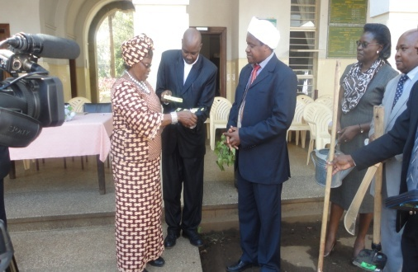
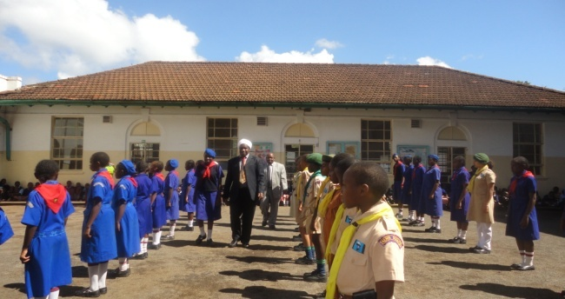
Director NEMA and KICD SDDMES inspect Head teacher and her Deputy of City Primary view items
guard of honour before presentation of items

- School clubs have been established
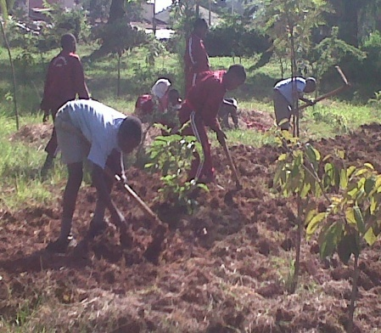
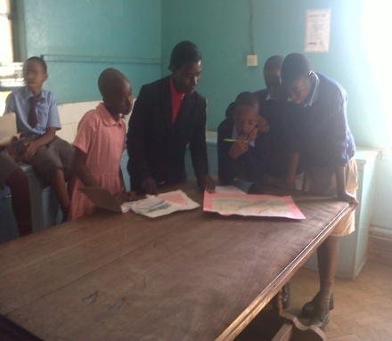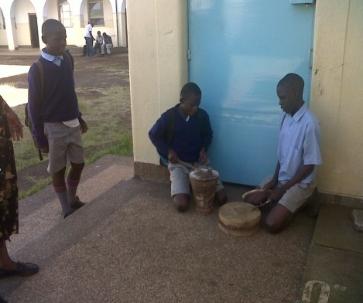
Art club, Music Club and Environmental Education Club in action
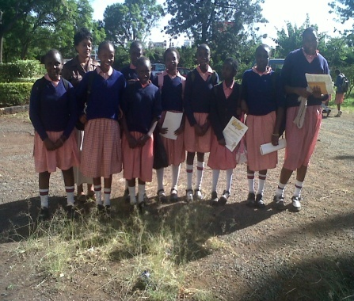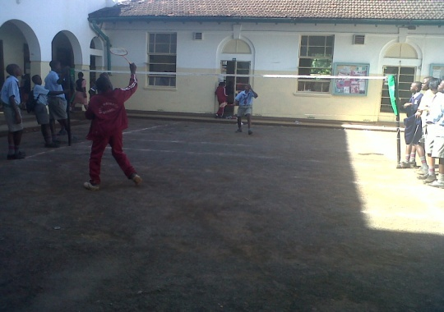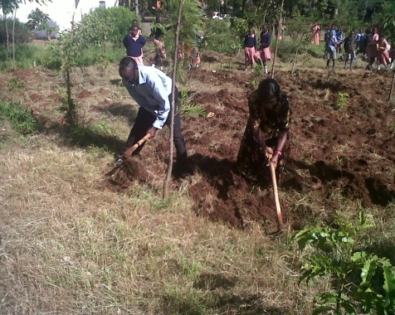
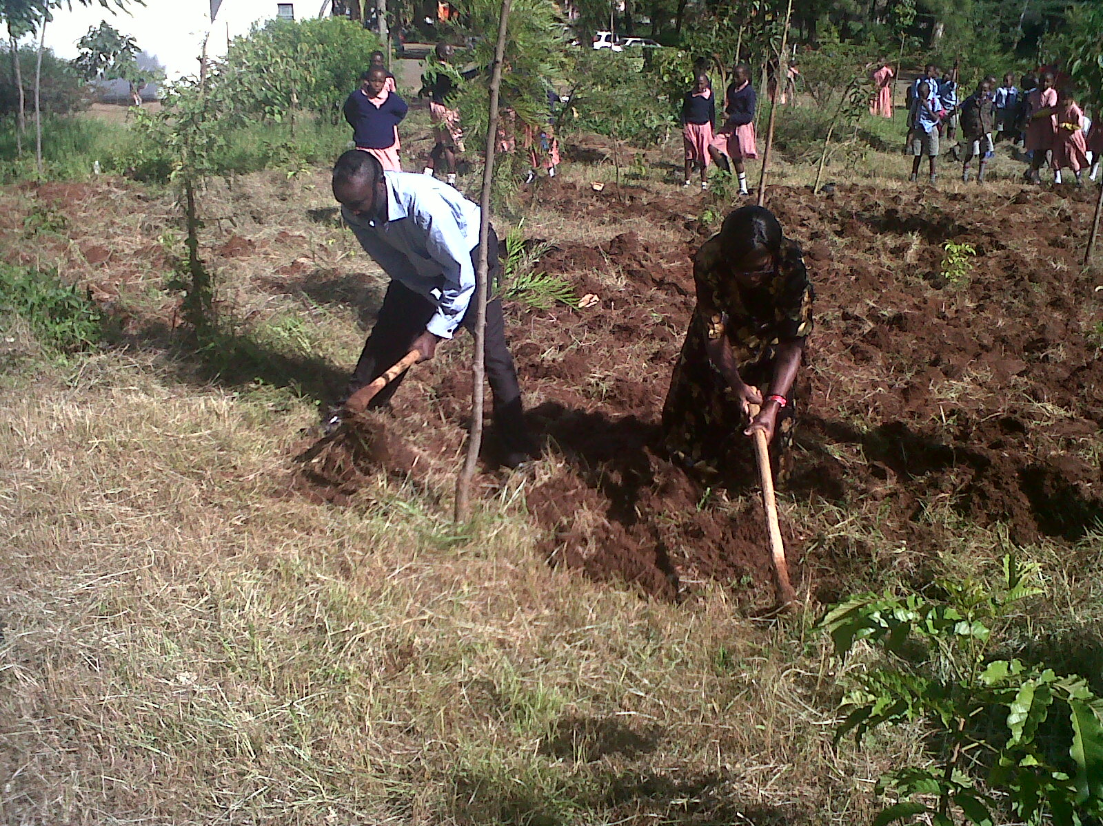
Bible Club Badminton Club Teacher Demonstration
- The Art club has been making drawings which are sold to hospitals e.g. Getrude’s Children’s Home and Embu Hospital
- The children in the environmental club did not know how to hold a jembe. It took demonstration from the teachers to guide them. Eventually they were able to dig the area they wanted to plant. They were taught how to harrow by the grounds man. The learners plant a variety of vegetables, groundnuts, maize and pumpkins. The food is sold to teachers and the Autistic unit who have been buying their vegetables from the nearby Ngara Market.
- The Sports section was enhanced with the introduction of Badminton through the support of the Chairperson of the Kenya Badminton Association. A member of staff was trained as a Trainers of Trainers for Nairobi region and equipment (Net, shuttle corks and rackets) was donated by the Association.
- The music club entertains visitors during school functions. It has a very talented drummer.
- Parents of learners with Autism have been in despair for a long time. Their children did not have a curriculum through which they could be taken progressively. The teachers would choose activities which they observed the learners were interested in and encourage them to participate in them. The challenge was presented to KICD and curricula has been developed for three learners with Autism in three levels:- Foundation, Intermediate and Pre- vocational levels. Teachers Handbooks have been developed to accompany the syllabuses. These are helpful to the teachers as they guide one on how to interpret the requirements of the syllabuses. It includes suggestions on the resources, teaching approaches, assessment methods and how the teacher may keep the records for each individual child to maintain good follow up for transition.
- The Special Unit Section has also joined in the farming activities. They have established their own ecological gardens alongside the regular learners. Additionally, they have received support from well wishers and have started rabbits and chicken rearing projects. These are also utilized by the regular pupils for relevant topics in their syllabus.
- The school has initiated garbage management and have been able to designate specific dustbins in which segregated garbage is put e.g. plastics, paper etc
- The school has established vegetable nurseries for the ecological gardens

6.0 CURRENT STATUS OF THE SCHOOL ACTIVITIES (PHOTOGRAPHIC)
1) Crop farming
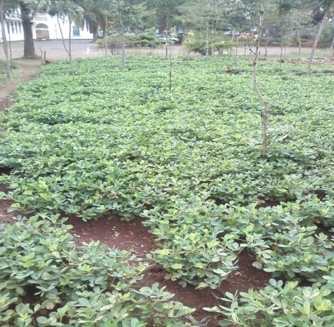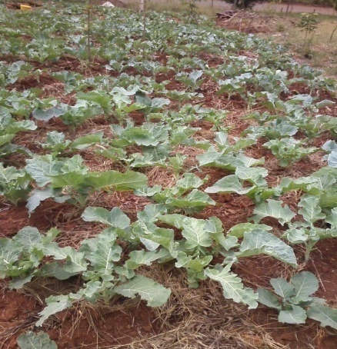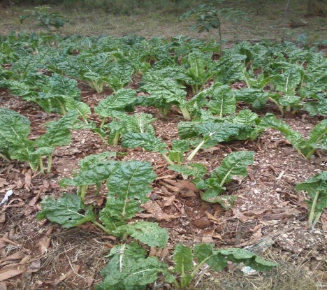
Groundnuts Kales (Sukuma Wiki) Spinach

2) Animal Farming
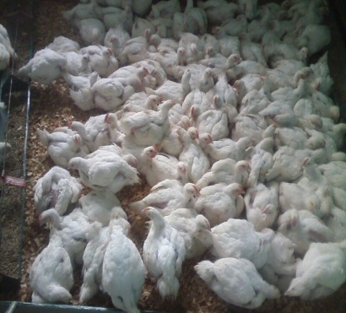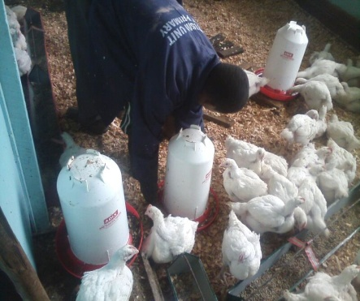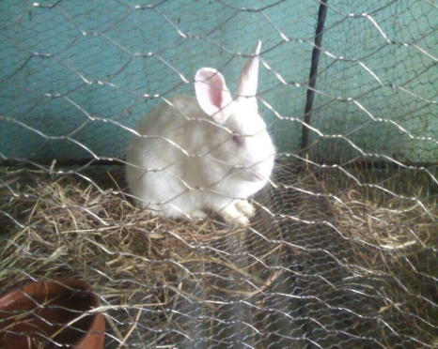
Chicken rearing Rabbit rearing
7.0 PROGRESSIVE INTERVENTIONS
In 2013, partners in the pilot NEMA and KICD proposed that there was need to widen the network of actors to include an evaluation component to help document the achievements and trace the value added in engagement of learners in the activities. The Education for Sustainable Development (ESD) demonstration centre project team was constituted to manage the Pilot Project at the Jamhuri High and City Primary Schools. The aim of the project as an open outdoor laboratory is to demonstrate how ESD concepts can be effectively implemented in institutions of learning. The project is to help in attitudinal and behavioral change so as to lead to sustainable development. The project is intended to enhance the ability of learners and teachers to acquire knowledge, skills, attitudes and values of sustainable development. The demonstration centres are developed to entrench skills of decision making, problem-solving, critical thinking and communication among others. The project also seeks to re-orient curriculum assessment and evaluation to take more recognition of the learner’s achievement of relevant competencies for various levels.

The core team overseeing the project draws membership from the National Environment Management Authority (NEMA), Keya Institute of Curriculum Development (KICD, formerly KIE), Kenya National Examinations Council (KNEC), and Kenya National Commission for UNESCO (KNATCOM), Ministry of Education Science and Technology (MoEST), Kenyatta University (KU), Kenya Organization for Environmental Education (KOEE) and participating teachers from Jamhuri High School and City Primary school. It is also expected that once the projects take root they will be able to embrace initiatives that will enable them to sustain themselves fully.
8.0 CONTINOUSTRAINING INITIATIVES
On 1st and 2ndJuly 2014, training on Mainstreaming ESD in the curriculum was conducted for teachers from schools around Nairobi including City Primary. A visit was arranged to visit Shree Kuchi Leeva Patel Samaj School in Nairobi West for Benchmarking. This is an Eco School undertaking the KOEE programme. It was expected that the teachers who attended would learn from the visit and be able to improve the activities they are carrying out in their school. The inclusion of teachers from other schools in the training was to facilitate the startup of similar activities in more schools. A total of 15 teachers from six schools were trained. These included four teachers from City Primary School.
9.0 OPPORTUNITIES
The implementation process has then following opportunities;
- Increasing the number of organizations to partner with as different needs of the school are identified
- Development of an efficient monitoring and evaluation framework that can provide results to guide policy in relation to curriculum review and reform
- Expansion of the programme to embrace more primary and secondary schools, thus creating a network for collaboration and experience sharing for sustainability of school projects
- Establishment of a mechanism through which the secondary school learners can mentor the primary school learners
10.0 CHALLENGES
The implementation of the pilot projects has faced the following challenges;
- Competing interests to complete the requirements of the curriculum to cover substantial theoretical work. The activities are carried out by the clubs. The activities are yet to be fully integrated in sync with classroom practice.
- Reluctance from teachers to rethink their traditional methods of teaching to embrace progressive and constructivist modes of teaching
- Lack of adequate funding and a properly designed programme for building the capacity of school managers/administrators, head teachers, teachers and school support staff on the concept of ESD an mainstreaming of ESD in the curriculum.
- Lack of a clear understanding of the concept of ESD amongst policy makers which sometimes leads to not receiving their support.

