Ecomuseums Planning Framework

March 4, 2013
This document is based on a workshop that took place in Regina on Feb. 21, 2013. Participants included over a dozen potential stakeholders and community leaders from across the province interested in the ecomuseum model. This framework is based on their comments and does not necessarily reflect the position of the provincial government.

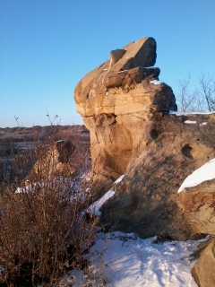
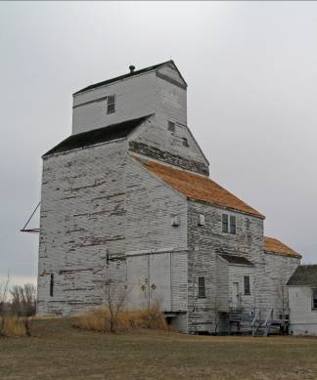
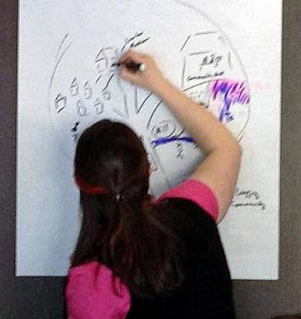

Vision

Ecomuseums will be understood, supported and thrive here as part of a network of dynamic, community-based interpretations of heritage, land use, history and culture.

The story of place includes the people, culture(s), community, relationships and interactions.

Rationale

There are reasons why eco-museums have come into existence elsewhere and are being considered in Saskatchewan, specifically:

- The concept of museums is changing. There is a shift in focus toward being a living heritage with community involvement in celebrating and planning culture.

- Ecomuseums reflect today as well as the past and the future. Where we are is based on where we have come from as well as where we are heading

- There is increased interest in telling the story of the place not just the people. The stories are being told in a dynamic inter-play between tradition, heritage, change, growth, and the communities living now on this land in this place.

- There is a need for stewardship to preserve what we value – and to prepare for and adapt to the future. Few communities have a place to gather to do this type of engagement.

An ecomuseum is the entire dynamic that happens in a landscape, including the businesses.
We are all exhibits in an ecomuseum.

Definition: Ecomuseum – (draft definitions from participants)

A holistic approach to understanding, interpreting and celebrating an authentic cultural landscape that encompasses the natural and built environments as well as natural and human-made processes, heritage and culture.

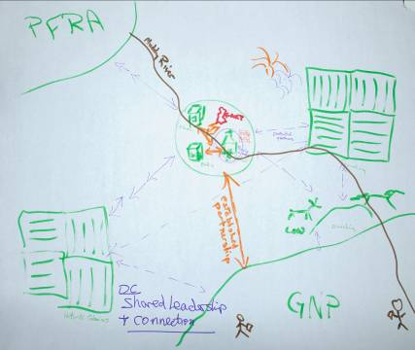
Holistic approaches to community engagement based on culture, traditions and assets that currently exist (lifestyle) so that people can adapt to change and growth and promote their unique region, heritage and sense of place.

Ecomuseums are designed to share the experience of place, community, people, and their natural and cultural heritage. They provide the opportunity for communities to actively participate in developing dynamic and fluid relationships and to share and learn about their stories in their own ways.

Principles

Ecomuseums rely on solid principles. The following are considered to be important:

- Community-based ownership and involvement: to help people enhance their quality of life by telling their own stories and facilitating discussion and participation (knowledge exchange)

- Authenticity: true to the people involved - we ourselves are coming up with the principles rather than trying to apply something we looked up in the literature

- Unique locations defined by community: interpreted by them and not for them - sharing folklore, traditional knowledge, scientific information, spirituality and personal discovery and expression

- Experiential, dynamic and community-led: a local place and vehicle for discussion and demonstration of culture, heritage, art, environment and economy

- Pride and identity: creates and focuses on pride of place via “place making” and celebrating the culture and heritage in that place

- Inclusive and collaborative engagement: of a wide range of community interests and stakeholders – creating a sense of belonging and being part of it

- Done by, not on behalf of, the community: in the spirit of learning and problem solving with shared leadership and stewardship

We are shaping contemporary society based on the histories and landscapes in our place.

Guiding Beliefs

The following were discussion points related to beliefs about ecomuseums:

- They need to be connected to Municipalities in some way or another
- There may not be any new money for ecomuseums, but aspects may be supported via current funding avenues
- Must be led from within the community (grass roots) not from an outside system
- Each ecomuseum will offer different things and have a unique story and approach
- There is a need for language/ terms to be well understood with flexible interpretation
- Not all ecomuseums would do or offer all things identified as possible
- The distinction between conventional and ecomuseums must be clear

Saskatchewan will need an ecomuseum framework that applies to urban, rural and northern settings

Describing Ecomuseums

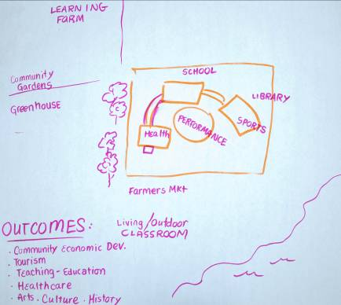
The following is an overview of ideas and thoughts to help clarify what goes on (or could be offered) at an ecomuseum.

Primary Focus of Ecomuseums:

- Culture, Heritage, Art, Environment, Economy
- Education and Information Sharing
- Facilitation of community discussions and planning
- Planning and Research
- Engagement and celebrations
- A very wide range of activities

Pursuing the development and maintenance of safe, vibrant communities through
partnerships, planning and participation.

Purpose of Ecomuseums:

- To be part of improving the overall quality of life (past/present/future) of a community and the surrounding area

- Living history in real time (connection to this moment being historic)

- Making connections between (and re-membering) heritage, culture, nature, people and economies

- Providing a place or forum for different value systems and a wide variety of interests to be part of the community

- Sustainable relationships for community-based activities that build pride and confidence in who we are, where we have come from and where we are going

- To provide a focus and link to research (qualitative and quantitative) – a place for discussion, stories and involvement to prepare for or shape change and transition

Key Concepts:
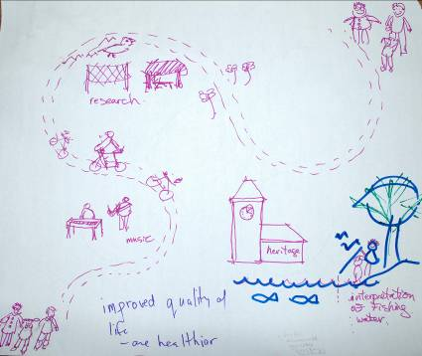
- Must be authentic, based on things happening right now, to you
- Not traditional or conventional museums (showing artifacts) – the people and their interactions are a distinguishing feature
- Linked to overall quality of life
- Ecomuseums are a way to help people think about and engage with culture and heritage in “place”
- Part of the community-based or creative industries with a focus on natural spaces
- An ecomuseum is a concept, but it’s also tangible; a cake with many ingredients
- Education, community development and identity are very much a part of it
- Often connected with economic development and tourism
- There is an increasing interest in “protecting prairie pastures”
- Reflects boundaries or territories that exist in a natural way, not necessarily by regions of government
- Think network rather than “owned territory”
- Done in a multi-cultural and ever-changing context

Possible Activities:

- Education and outreach (visitors and community members)
- Planning (area, community agreements, sustainable development, stewardship)
- Research – community consultations, measuring change and impacts; university partnerships
- Community gatherings, celebrations, festivals
- Make it come alive
- Tours (guided or self-directed)
- Communication and dialogue forum
- Collecting information, stories, heritage

What an Ecomuseum is Not:

- Not solely about the environment or about culture
- Not stagnate – it is living
- Not just a building
- Leadership is not coming from the outside of the community
- It is not a few people, exclusive
- Not just preservation, environment or the traditional idea of a museum
- Not isolated – but has soft boundaries – interconnected
- Not passive (take something away), not fake (authentic)

Some don’t like the words museum or eco – risk of Ecomuseum being another buzzword

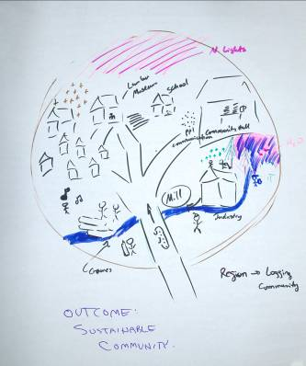
Desired Outcomes:

- Enhanced quality of life for community
- Makes the community a place people want to be; a sense of belonging
- Spin- off benefits such as tourism and economic development
- Partnerships with the community
- Acknowledgement and education about local history (showcase and share)

Combining the nature perspective and the heritage perspective
to foster a sustainable community.

Key Question: How do we define an ecomuseum as being something different or unique – we have to convince our organizations about what it is and why we should be part of it (how does it add value to what we are doing, or is it separate from it?).

The Saskatchewan Perspective

Environmental Scan

The following is an overview of Saskatchewan as it relates to supporting or limiting the further development of ecomuseums.

Positive Trends:

- The world is a much smaller place and social media has helped with this
- Support for community cultural planning
- There is funding for some of the activities done in ecomuseums
- Volunteer base with more global experience and education
- Rapid pace of change that has awaken a new demographic

Analysis:

Take advantage of the opportunities that are currently present – community excitement, funding from government, new demographic and resurgence of interest in community.

- People coming to (and coming back to SK) with increased interest in the fabric of the province
- Renewed interest in keeping communities alive and making them viable
- Economy is healthy
- Cultural policy is a starting to point for discussion with government
- SaskCulture is supporting engagement and planning at community level
- Interest at all levels to reinvest in infrastructure
- Desire to experience the authentic (personal – boomers interest in heritage)
- Education levels demand a different experience beyond looking at exhibits and artifacts
- Movement and interest in reconnecting to nature and value of leisure time
- Looking for meaningful leisure experiences

Analysis:

There is optimism and opportunity – ecomuseums could foster the creation of unique identity, pride of place and locations where people want to live, visit and invest.

Negative Trends:

- Decreasing visitation in certain areas and with museums
- Fragmented funding
- Hard to quantify experiences as a result of an ecomuseum
- Increasing costs and finding resources
- Difficult finding and keeping volunteers
- Relationships take time (between different groups and sectors)
- Visitor expectations (instant gratification)
- Competing with technology and busy life styles (over-wired world)
- Time consuming to create something relevant and thoughtful (vs. new booming demographics)
- Hard to sell value of relationships

Analysis:

Ecomuseums might be necessary for community sustainability – they need a plan and champion to keep moving. Society needs vision and an ecomuseum could help to develop and realize that vision at the community level.

- We live in a highly altered province facing a range of conservation issues
- Resource development needs to be pursued in ways that consider impacts on our natural heritage
- The provincial government is interested in growth, but not growth for growth’s sake
- Communities are dealing with many demands, increasing the risk of volunteer “burnout”
- Young families may be less able to be involved, especially those with two incomes
- Heritage seems to be less visible in recent education curriculum
- Arts and cultural training would benefit from support over the long term

Analysis:

We need to make it clear, join hands, speak out, move forward, burn out - rise again – make it clearer and repeat.

Moving Forward

The following items were identified as needed in order to proceed:

- A clearly articulated definition
- A plan and case for pursuing the concept -best ways to explain it
- Meaningful principles and defined targets and goals
- Define boundaries/scope - too all encompassing - confusion with tourism
- Develop a Saskatchewan Framework for Ecomuseums
- The Steering Committee could use this information to develop the framework
- Further discussion (forum) to maintain momentum – a sense of urgency
- More pubic education – with examples - Pilots in 2 – 3 places
- Establish funding criteria – for assessment, adjudication – demonstrated outcomes
- Determine uniqueness to communities – ensure it is not a band-aid solution

Next Steps

- Identify potential pilot sites that could become examples or models of different types of eco-museums (outline clear benefits to becoming a pilot site)

- Host another forum (electronic?) to continue the discussion

- The Steering committee will finalize the framework and present it back to the group. Note: this should happen in the very near future.

- A smaller task team should be established to define the Saskatchewan Model and then share it with the larger group to finalize.
Action Plan Summary

Action | Description | Status
Planning | Finalize the Saskatchewan Ecomuseum Framework | Underway – to continue after the meeting February 21, 2013
Data Collection | Establish a data base of existing models so we know what currently exists in SK | To be developed  Heritage Canada has a data base of funders  Each participant to send a paragraph to Glenn describing their museum
Membership/Network | Form a network of service providers and stakeholders and continue to grow it | Underway with 22 people plus organizational reps as part of the network – Glenn to develop and coordinate further connections
Research | Set research priorities – explore other jurisdictions for relevant models to validate, inspire and demonstrate | Underway – Steering committee will continue process and share with the group
Implementation | Develop a clear strategy to move from where we are to where we want to be with ecomuseums in Saskatchewan | Steering Committee to discuss and have as an agenda item for next large group discussion

