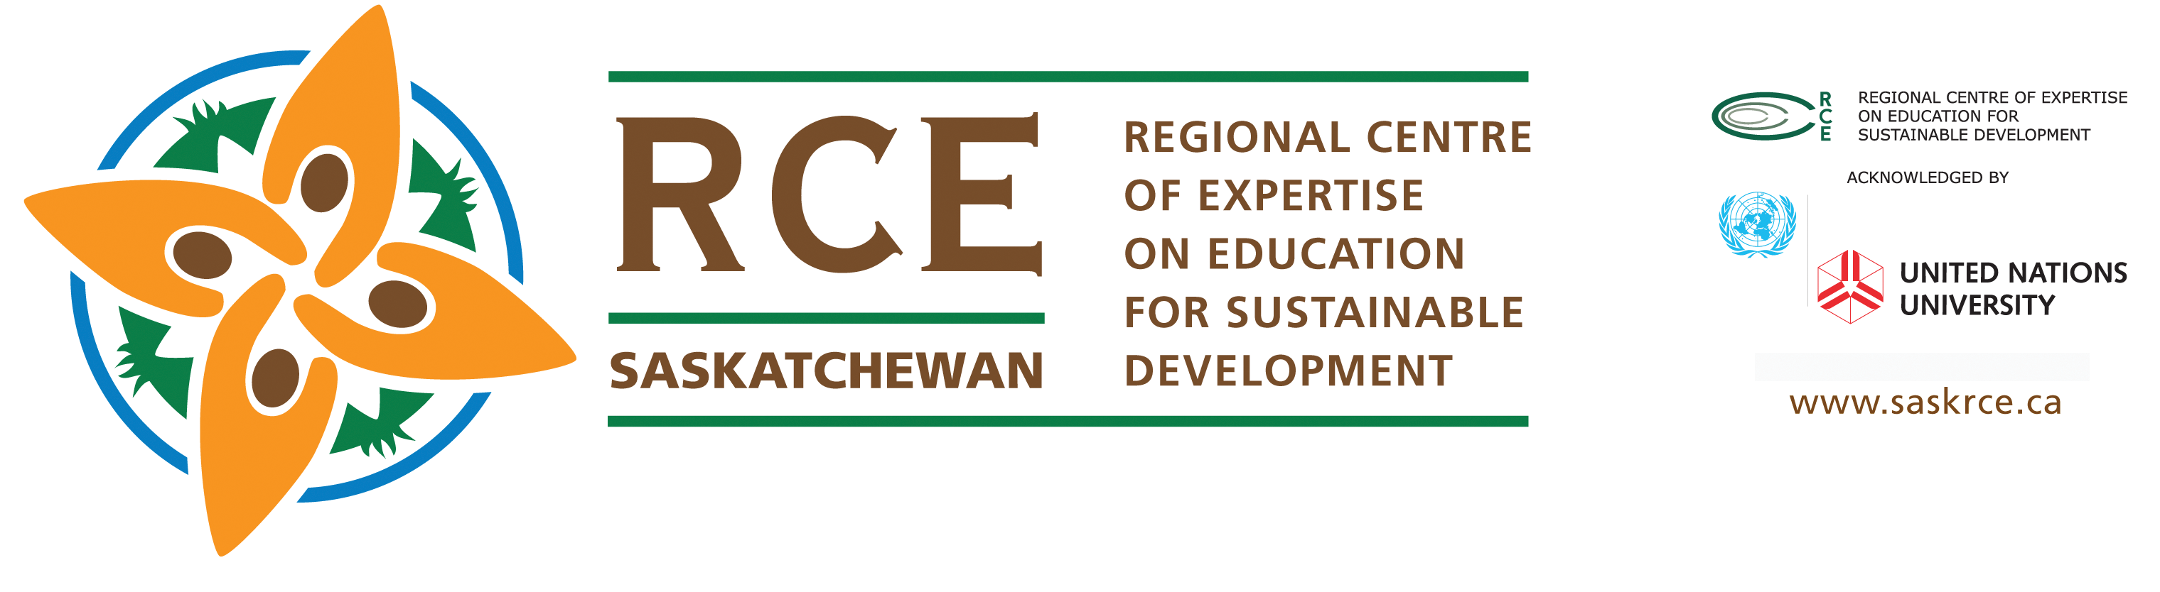

November 2013

RCE AMERICA’s
Continental Collaboration 2013 -2014
RCE Saskatchewan
(EXAMPLE TEMPLATE)

Main Question for RCE America’s to consider:
“How do we work ‘continentally’ to engage all of our RCE Americas to ‘collaboratively’ and ‘cooperatively’ identify and resolve similar ESD issues, challenges, and opportunities?”

#1) What is working in your RCE? (Saskatchewan Example)
- RCE Recognition Events from 2008 to 2013 “celebrating” ESD in the region
- Collaboration/Research and visits from other RCE’s globally (Australia, Korea: October 2013)
- Development of Position Papers (Uranium presentation, SSCHRC)
- Publications (Case Studies) in books and Journals (Ch.7: the Challenge of Sustainability”
- Meetings with Federation of Saskatchewan Indian Nations (FSIN) May 2013
- Working collaboratively with national organizations such as ESD Canada, LSF, SEEDS Foundation
- Partnering with other organizations such as SEdA Town of Nipawin to develop focus on ESD Themes and professional development
h) Mentoring new global RCE’s (Quebec, Greater Portland, Australia)
I) Partnering with Grand Rapids for High School Water Research
j)

#2) What could we doing BETTER as a collaborative group of RCE America’s?
- Focus on regular (quarterly) communication (Skype/video/phone conferences
- Develop ACTION plans identifying WHAT, WHO, HOW (by) WHEN)
- Sharing more information through the UNU-IAS Portals
- Engaging other Continental RCE’s in one meeting per year via technology

…..2

(2)

#3) What ISSUES, Challenges and OPPORTUNITIES can we move forward
with and after the 8th World RCE conference’s in Nairobi (November 2013)?
- Indigenous/Aboriginal collaboration and research on Traditional Ways of Knowing and Learning ESD
- Climate Change
- Water Issues
- Development of YOUTH VOICE in each of the RCE’s
- Planning for DESD in 2014 in Japan and…. “Beyond”

#4) Other RCE America’s ideas developed from 8th Global RCE Conference in
Nairobi, 2013:
- Discussion of the next “Conference of the America’s” in 2014 (Host/Date)

Lyle A. M. Benko: Co-Coordinator: www.saskrce.ca
Phone: (306) 949-7992 Fax: (306) 585-4880
E-mail: lyle.benko@sasktel.net

