Whole-Institution approach of RCE Greater Dhaka through Water Reuse and Youth Mobilization in Commitment to GAP (Global Actions Programme)
Professor Mohammed Ataur Rahman
Coordinator, RCE Greater Dhaka, Bangladesh

Summary

In combating environmental challenges to pursue Sustainable Development Goals (SDGs), RCE Greater Dhaka has been taking various steps according to Global Actions Programme (GAP) to speed up SDGs through sustainable education. Among the five priority action areas of GAP, it includes integrating sustainability practices into education and training (whole-institution approaches), empowering and mobilizing the youths.

RCE Greater Dhaka is a pioneer institution, playing a crucial role in disseminating sustainable education to students, youths and community. The sustainability practices that the institute has taken so far are promoting compulsory sustainability education for the undergraduates, practicing in its green campus. The sustainability education includes saving natural resources, i.e., energy, water, food, waste recycling; organic farming, solar electricity, campus biodiversity and recently added greywater treatment plant to reuse greywater from washroom and cafeteria for watering the gardens and lawns. Moreover, IUBAT University is harvesting rainwater from its buildings and storing in the pond for multipurpose research, e.g. fish cultivation, duck and live stocks farming and to recharge groundwater.

RCE Greater Dhaka has organized a youth forum who is actively working on cleaning Uttara, segregation of waste at source, and recycling; planting trees especially medicinal and fruit trees; awareness building on Biodiversity and for keeping functional ecosystem services. Moreover, ESD trained youth group has taken a yearlong “Save the Planet Earth and Keep the Ecosystem Services Functional” program in the schools and colleges, on the occasion of nationwide celebration of Silver Jubilee of IUBAT University, the host organization of RCE Greater Dhaka.

Introduction

Education for Sustainable Development (ESD) is a United Nations (UN) decade long program (2005-2015) playing a crucial role in formal and non-formal education in up scaling sustainable development around the world. It is marking its role in educating students, teachers, community and government about sustainability. This education means an action oriented life-long learning about sustainable development and through learning an overall change in behavior and practice towards nature. This is unique in that sense that knowledge of sustainability takes considerable time to realize and a whole behavioral change requires accustoming to this. This realization and behavioral change comes from individual to community to nationwide change. In this respect any academic institution could play as a front runner for sustainability practices as a whole. A model whole-institution approach of an organization educating its people and then spreading the actions towards surrounding community is cultivating in RCE Greater Dhaka, Bangladesh. This case study discusses about this Whole Institution approach of RCE Greater Dhaka in biodiversity conservation, youth mobilization, and water reuse.

Education for Sustainable Development (ESD)
According to UN Resolution on Environment and Sustainable Development, Implementation of Agenda 21 termed “United Nations Decade of Education for Sustainable Development (DESD 2005-2014)” emphasized that education is an indispensable element for achieving sustainable development and decides to proclaim the ten-year period beginning on 1 January 2005 the United Nations Decade of Education for Sustainable Development. In 2003, in response to the UN resolution on the UNDESD, the United Nations University Institute for the Advanced Studies (UNU-IAS) launched the ESD project, with funding support from the Ministry of Environment, Japan. The ESD project designed and implemented research and development activities through two flagship initiatives: a global multi-stakeholder global network of Regional Centres of Expertise on ESD (RCEs) and a network of higher education institutions called the Promotion of Sustainability in Postgraduate Education and Research Network [1].
Moving forward, UNESCO has now presented the Roadmap for Implementing the Global Action Programme (GAP) on ESD with its five priority areas of action: advancing policy by mainstreaming ESD, transforming learning and training environments using the whole-institution approach, building capacities of educators and trainers, empowering and mobilizing youth, and finally accelerating sustainable solutions at the local level. At all levels of society, RCEs play a crucial role in implementing these goals using their local knowledge and global network and the RCE Greater Dhaka has been significantly contributing in this regard.

Challenges of RCE Greater Dhaka
Bangladesh is a tropical monsoon country in South Asian Region. It is a funnel shaped deltaic floodplain of the Ganges, Brahmaputra, Meghna, Karnofuli, Shangu and Matamuhuri rivers meets to the Bay of Bengal. The northern and eastern boundaries are the hills of eastern Himalayas and Arakan and Lusai ranges respectively. Huge monsoon rainfall brings silt and organic matters to the downstream and made the most fertile region of the world with the highest population. However, hundreds of tributaries and distributaries help growing food crops, fibres and many other cash crops including bamboos and timbers etc. But to feed the huge population, short-term benefited technologies especially high inputs depended ones, excessive use of chemical fertilizers and pesticides, deforestation in and around the region, change of the landscape, unplanned urbanization and industrialization especially textile, dyeing, hide and skin and medicine industries etc. have polluted the environment especially the air, soil, water-bodies and thus the ecosystem services are becoming less functional and affecting the human health as well as other lives. These enforced huge rural population especially from the vulnerable coastal zone to migrate to Dhaka megacity. It is also regarded as one of the most unlivable enclosed coastal megacity in the world [2]. Therefore, RCE Greater Dhaka has already taken different initiatives through adapting sustainability approaches and thus facing the challenges.

Whole Institution Approach

Whole-institution approach refers to the second priority area of Global Action Programme (GAP) in transforming learning and training environments. In this respect RCE Greater Dhaka is taking whole-institution approach in its IUBAT University campus and transmitting the knowledge in the greater community of the country. The university campus is a green campus with plenty of biodiversity, cultivating resource saving initiatives and mobilizing youth in various schools surrounding the campus by sustainable entrepreneurship skill development. This initiative is unique in the context of Bangladesh where RCE Greater Dhaka is the single RCE in the country spreading sustainable education.

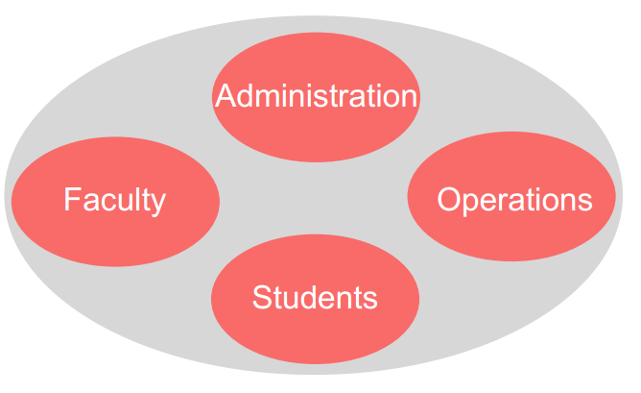
Figure 1: Whole Institution Approach

- Administration: Biodiversity conservation in campus situated in metropolis
- Faculty: Mandatory inclusion of Environmental Sustainability course in undergraduate level
- Operations: Greywater recycling
- Students: Youth mobilization in and outside campus of different institutes

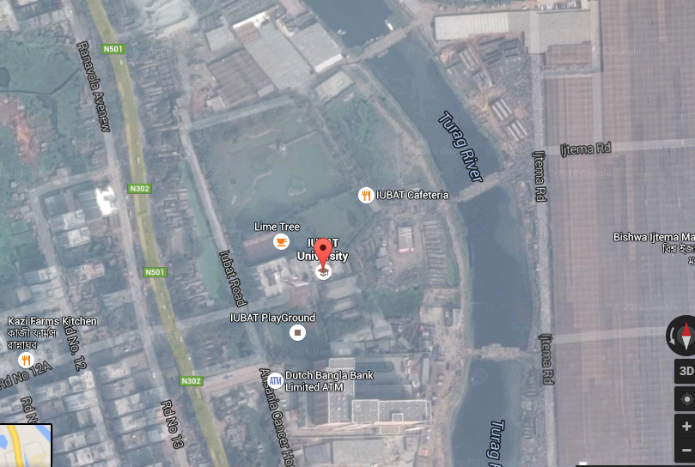

Fig 2: IUBAT University secretariat of RCE Greater Dhaka

Activities done RCE Greater Dhaka
- Introducing Environmental Science and Sustainability as a mandatory course for all undergraduates
- Trained up 5000 undergraduates with ESD skills
- Momentum of Green Campus movement in IUBAT University i.e. energy save, water save, waste management, greywater treatment and reuse
- Climate change education among students’ body of the university
- Youth conference organized by RCE Greater Dhaka Youth Forum in September, 2015
- Social awareness on waste management practices through Cleaning campaign in IUBAT campus and surrounding urban community, Uttara, Dhaka
- Achieving national environment award in 2015 by introducing local knowledge and traditional practices to protect climate change induced drought
- Research publication was made on practices to protect climate change induced drought in 2015
- Social movement for awareness building on traditional knowledge for disaster management through participating in the National environmental fair 2015
- Highlighted ESD in Bangladesh in BAPA-BEN conference on "Environmental Policies and Acts Implementation Problems”, Dhaka, 2015 by presenting a scientific paper.
- Youth participation in YUVA Meet in Delhi, India in February 2015.
- Organized workshops on ESD practices in different Schools and Colleges of Uttara, Dhaka, 2015.
- RCE Greater Dhaka started working with IUNCBD- International University Network on Cultural and Biological Diversity and Prof. Dr. M A Rahman took participation in the conference in Delhi, 2015.
- RCE Greater Dhaka started leading WWOOF- World Wide Opportunities on Organic Farming as Prof. Dr. M A Rahman became the Director of this organization in Conference in Turkey Sep. 2014.
- RCE Greater Dhaka participated in Sejhatera Forest opening ceremony in South Korea as Dr M Rehan Dastagir took part in May 2015.
- Youth of RCE Greater Dhaka campaigned in schools in Dhaka in 2015, 2016.
- Case study presentation in 8th AP RCE Meeting on ESD held in Cebu and Bohol, Philippines, 5th to 8th March, 2015 by Dr M R Dastagir. Title of the presentation: Sustainable Rural Development through KBAD Program: A Case Study of RCE Greater Dhaka.

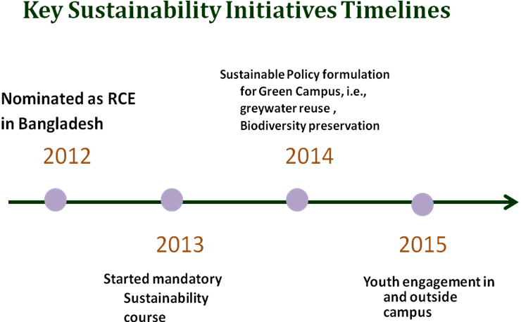

Figure 3: Timeline for the Whole Institute Approach of the campus

I) Administration: Biodiversity Conservation

Dhaka is the 18th most populated city in the world. Due to unplanned urbanization and industrialization the environmental condition of this city has been deteriorated severely and now Dhaka is one of the unlivable cities in the world. One of the main reasons is the scarcity of greenery. IUBAT University is situated in Uttara Model Town of Dhaka metropolitan area which lacks biodiversity predominantly. However, the campus was established in 2005 on a barren land. RCE Greater Dhaka started its biodiversity activities to introduce indigenous and exotic species in the campus for greening the campus with biodiversity and has developed an eco-campus. The green campus has 86 varieties of tree species with a total number of 777 on an area of 2.6 hectares [3]. Moreover, the campus is a learning laboratory for the students for various herbs, under-utilized crops and ornamental plants, and it becomes a habitat of thousands of birds. This is done with the administrative support from the university whose initial plan was to make a green campus. These perennials plants include local and exotic species. This also plays as a laboratory for identification of plants to the students who have very little knowledge about plants.
The chronological development of the campus is given below:

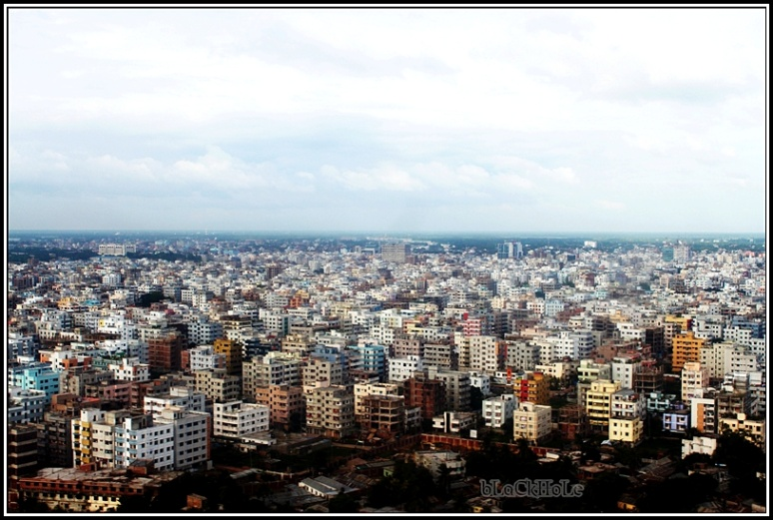

Figure 4: Lack of green cover in Uttara, Dhaka

In 2007 In 2016

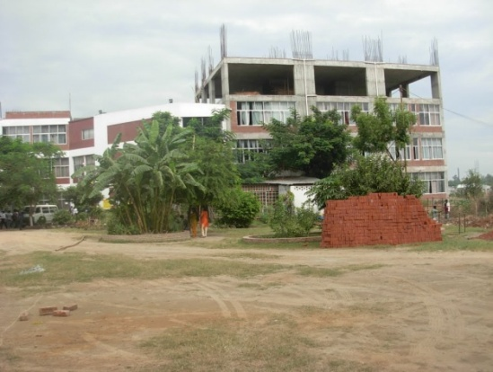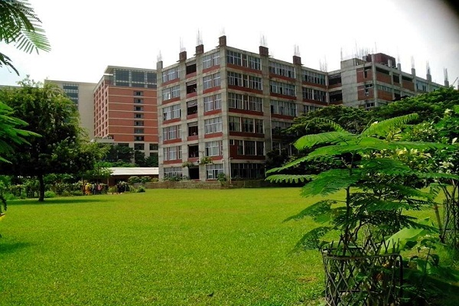

In 2008 In 2016

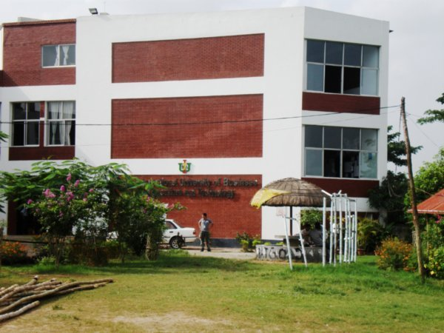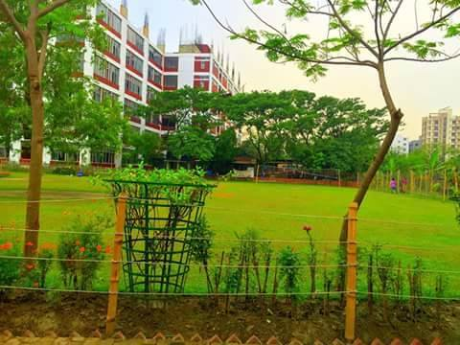

In 2009 In 2016

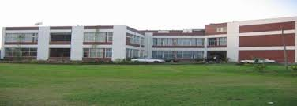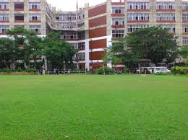

Figure 5: IUBAT University greening initiatives in course of time

Table 1: Plant Biodiversity in IUBAT University campus
SL | Common Name | Scientific Name | Family | Number
1 | Krishnachura | Delonix regia | Fabaceae | 131
2 | Mahogany | Swietenia macrophyllus | Meliaceae | 85
3 | Alamanda | Allamanda cathartica | Apocynaceae | 35
4 | Thuja | Platycladus orientalis | Cupressaceae | 30
5 | Banana | Musa acumita | Musaceae | 25
6 | Mango | Mangifera indica | Anacardiaceae | 23
7 | Jackfruit | Artocarpus heterophyllus | Moraceae | 20
8 | Chip Bash(Bamboo) | Bambusa sp. | Poaceae | 20
9 | Palmyra palm | Borassus flabellifer | Arecaceae | 18
10 | Guava | Psidium guajava | Myrtaceae | 13
11 | Baganbilas | Bougainvillea spectabilis | Nyctaginaceae | 10
12 | Ixora/Rangon | Ixora coccinea | Rubiaceae | 10
13 | Ivory Cane Palm | Pinanga coronata | Aracaceae | 10
14 | Basil/Tulsi | Ocimum tenuiflorum | Lamiaceae | 10
15 | Mast Tree/Debdaru | Polyalthia longifolia | Annonaceae | 8
16 | Gmelina/Gamar | Gmelina arbroea | Lamiaceae | 8
17 | Plum/Boroi | Zizphus mauritiana | Rhamnaceae | 8
18 | Lemon/Lebu | Citrus limon | Rutaceae | 8
19 | Bokul | Mimosops elengi | Sapotaceae | 7
20 | Arjun | Terminalia arjuna | Combretaceae | 6
21 | Rain tree | Albizia saman | Fabaceae | 5
22 | Fig/Bot | Ficus religiosa | Moraceae | 5
23 | Neem | Azadirachta indica | Meliaceae | 5
24 | Blackberry/Kalojam | Syzgium cumini | Myrtaceae | 5
25 | Cinamon/Daruchini | Cinamomum verum | Lauraceae | 5
26 | Kadam | Neolamarckia cadamba | Rubiaceae | 5
27 | Madhobilota | Hiptage benghalensis | Malpighiaceae | 5
28 | Oil palm | Elaeis guineensis | Arecaeae | 4
29 | Shishu | Dalbergia sissoo | Fabaceae | 4
30 | Papaya | Carica papaya | Caricaceae | 4
31 | Coconut | Cocos mucifere | Arecaceae | 4
32 | Togor | Tabernaemontana divaricata | Apocynaceae | 4
33 | Kathgolap | Plumeria rubra | Apocynaceae | 4
34 | Rajkoroi | Albizia richardiana | Fabaceae | 3
35 | Cycas | Cycas pectinatus | Cycadaceae | 3
36 | Jarul | Lagerstroemia speciosa | Lythraceae | 3
37 | Kopper’s tree | Peltophorum pterocarpum | Fabaceae | 3
38 | Ataphol | Annona cherimola | Annonaceae | 3
39 | Bay leaf/Tejpata | Cinamomum tamala | Lauraceae | 3
40 | Ebony/Bilati gaab | Diospyros blancoi | Ebenaceae | 3
41 | Olive/Jalpai | Elaeocarpus floribundus | Elacocarpaceae | 3
42 | Kamini | Murraya paniculata | Rutaceae | 3
43 | Sunalu | Cassia fistula | Fabaceae | 2
44 | Pomegranate/Dalim | Punica granatum | Lythraceae | 2
45 | Areca nut/Supari | Areca catechu | Arecaeae | 2
46 | Starfruit/Kamranga | Averrhoa carambola | Oxalidaceae | 2
47 | Amloki | Emblica officinalis | Phyllanthaceae | 2
48 | Litchi | Litchi chinensis | Sapindaceae | 2
49 | Hog plum/Amra | Spondias dulcis | Anacardiaceae | 2
50 | Date/Khejur | Phoenix dactylifera | Arecaceae | 2
51 | Clove/Lobongo | Syzygium aromaticum | Myrtacaea | 2
52 | Wax apple/Jamrul | Syzygium samarangense | Myrtaceae | 2
53 | Monkey jack/Deowa | Artocarpus lacucha | Moraceae | 2
54 | Cardamom/Elach | Elettaria cardamomum | Zingiberaceae | 2
55 | Henna/Mehedi | Lawsonia innermis | Lythraceae | 2
56 | Garcinia/Kao | Garcinia cowa | Clusiaceae | 3
57 | Tamarind/Tetul | Tamarindus indica | Fabaceae | 1
58 | Drumstick/Sajna | Moringa oleifera | Moringaceae | 1
59 | Sapodita/Sofeda | Achras sapota | sapotaceae | 3
60 | Castor/Veranda | Ricinus communis | Euphorbiaceae | 1
61 | Dragon fruit | Hylocereous undatus | Cactaceae | 1
62 | Pomelo/Jambura | Citrus maxima | Rutaceae | 1
63 | Wood apple/Bel | Aegle marmelos | Rutaceae | 1
64 | Avocado | Persea americana | Lauraceae | 1
65 | Lotkon | Baccaurea sapida | Phyllanthaceae | 1
66 | Fig/Dumur | Ficus carica | Moraceae | 1
67 | Agar tree | Aquilaria malaccenaia | Thymelaeaceae | 1
68 | Elephant apple/Chalta | Dillenia indica | Dilleniceae | 1
69 | Wax apple/Golap jam | Syzygium jambos | Mytaceae | 1
70 | Orboroi | Phyllanthus acidus | Phyllanthaceae | 2
71 | Malotilata | Combretum indicum | Combretaceae | 10
72 | Myrobalan/Haritaki | Terminalia chebula | Combretaceae | 1
73 | Grape/Angur | Vitis vinifera | Vitaceae | 6
74 | Rambutam | Nephelium lappaceum | Sapindaceae | 1
75 | Sonalu | Cassia fistula | Fabaceae | 1
76 | Marula Tree | Scelerocarya birrea | Anacardiaceae | 6
77 | Musanda | Mussaenda erythrophylla | Rubiaceae | 3
78 | Shehora | Streblus asper | Moraceae | 5
78 | Acai palm | Euterpe oleracea | Arecaceae | 1
79 | Custard apple/Sharifa | Annona squamosa | Annonnaceae | 3
80 | Basil/Babui Tulsi | Ocimum basilicum | Lamiaceae | 10
81 | Pitali | Trewia nudiflora | Euphorbiaceae | 17
82 | Peacock/Radhachura | Caesalpinia pulcherrima | Fabaceae | 5
83 | Arjuna/Arjun | Terminalia arjuna | Combretaceae | 2
84 | Jiga/Jeol Bhadi | Lannea coromandelica | Anacadiaceae | 5
85 | Karinda/ Karamcha | Carissa carandas | Apocynaceae | 1
86 | Kanchon | Phanera variegata | Fabaceae | 1
Total |  |  |  | 777

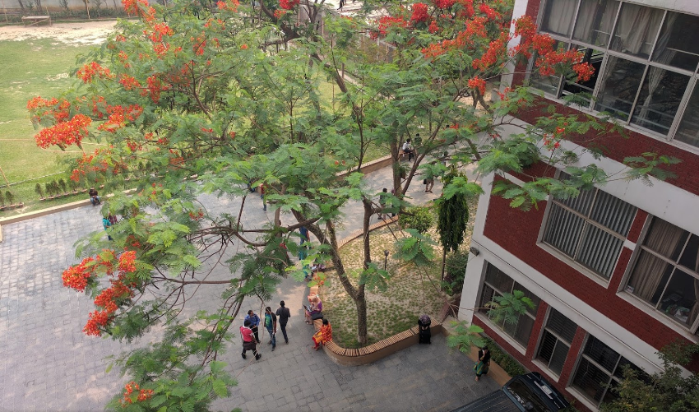

Figure 6: Dominant variety of IUBAT University, Krishnochura (Delonix regia)

University transport:

It is a unique facility that the university provides 30 bus services to all corner of Dhaka metropolitan city. As a result there is least car parked in the campus parking area. It reduces traffic jam, carbon emission and daily hazard to the student’s city life. “We feel very comfortable and safe to travel from any corner in the city in the university buses in the rush office time when public transportations are very hazardous and expensive” said by Rayhan, a student of BBA.

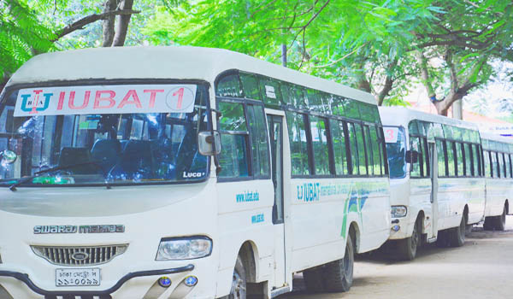
Figure 7: IUBAT University transportation

- Faculty
In Bangladesh, Sustainability course was first proposed in IUBAT-International University of Business Agriculture and Technology in September, 2013 for all students. This university has a regular eight thousands students and our plan is to skill up sixteen thousands hands to do sustainable actions for the country. The course curricula and sustainability practices is designed for the behavioral changes of the students. This sustainability course sets a pioneer ESD practices tools in Bangladesh.
The Course Design:
In course design we tried to maintain sequential learning and description of the following contents in utmost priority:
- Sustainable resource utilization
- Population and human resource and its sustainable management
- Climatic zones and Biodiversity
- Traditional wisdom in the centre of all sustainable practices
- Sustainability in school campus as a learning laboratory
- Soil, air and water pollution and food chain degradation and diseases
- Reclamation of Soil, Water and Air by various methods
- Environmental Health and Safety measures for the workers
- Environmental Ethics

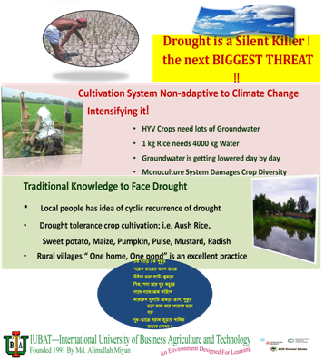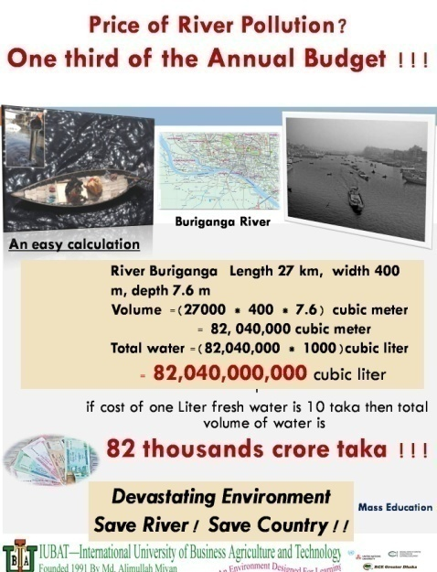

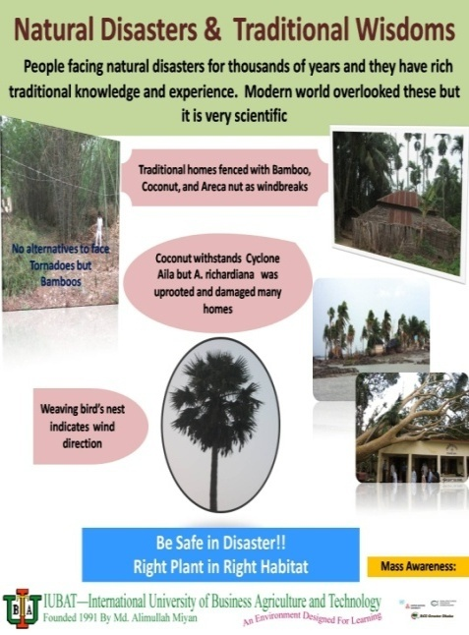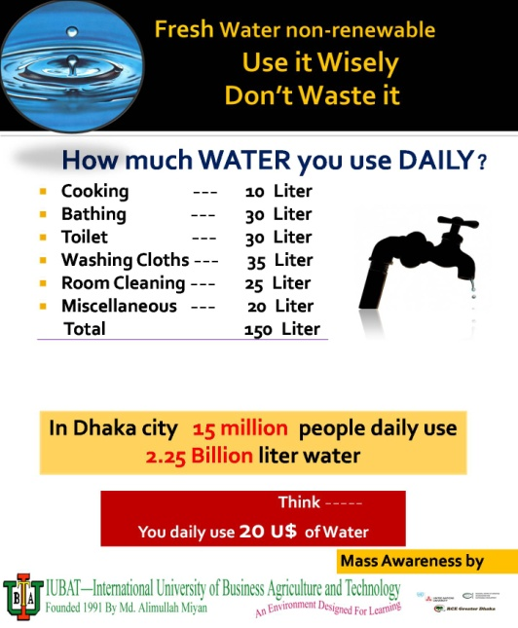

Figure 8: Sample Teaching Materials
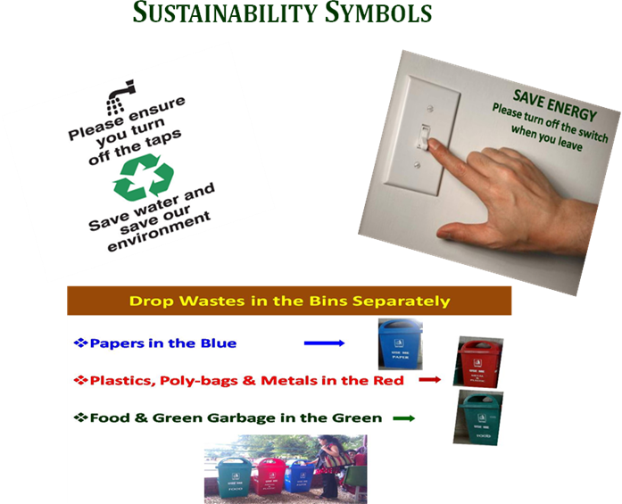

Figure 9: Sustainability practices in the campus

III) Operations
Water reuse by greywater recycling plant:
Water is a valuable resource but the availability of freshwater is very limited (< 1%) in the world. One way use of freshwater makes it nearly exhaustible in the country and in the Dhaka city the situation is worst due to one way consumption of freshwater every day by its 15 million people. There is no practice of reuse of greywater (used water) in the cities. Reuse of water could considerably decrease the pressure on fresh water. In the country, alarmingly groundwater level is decreasing at a rate one meter a year. In this situation no other option is open for us except reusing of greywater. Greywater recycling plant is a novel method of treating used water and makes it fresh. Recently operated Greywater treatment plant in IUBAT is saving 10500 liters of water every day.

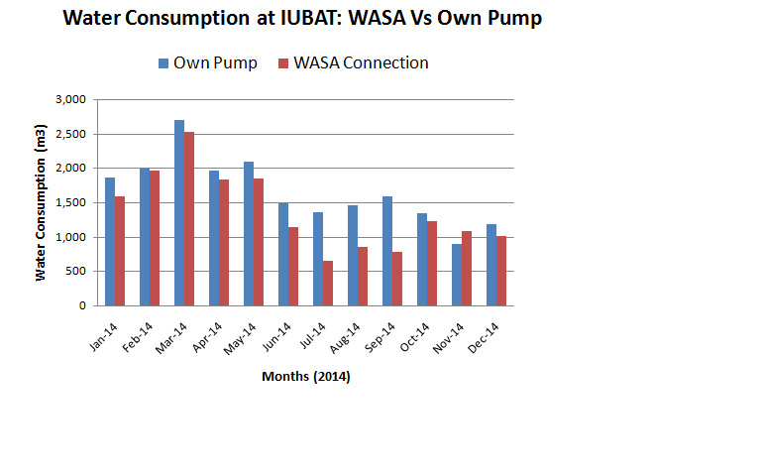
Fig 10: Water consumption in IUBAT University in different months of the year

Table 2: Sector wise use of water in the university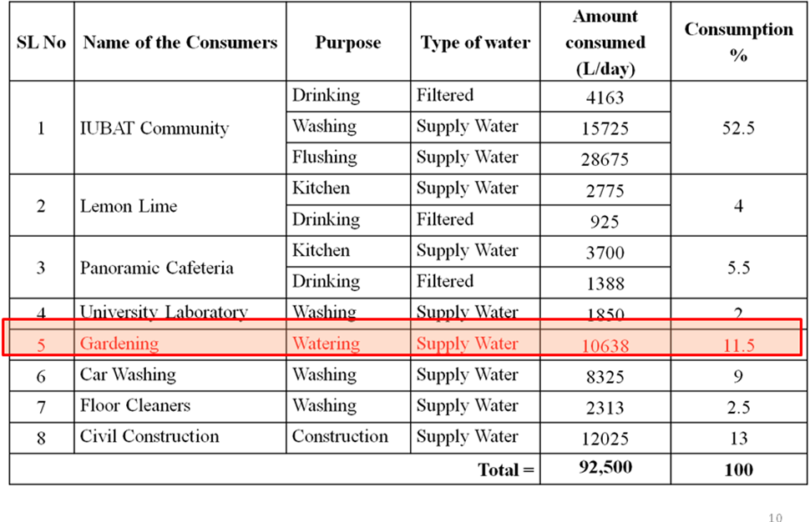

This real scale plant for re-using water for gardening is saving money and contributing to green concept by reducing waste water generation [4].
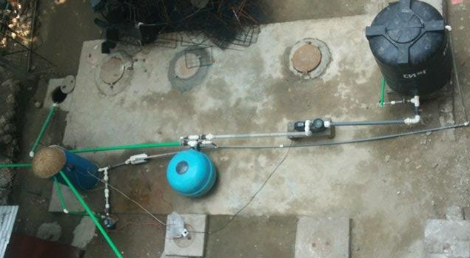
Fig 11: Greywater recycling plant
IV) Students: Youth Engagement
During the 8th Global RCE Meeting in Philippines, 2015, RCE Greater Dhaka was leading the Youth Session. It was focused that community or social work should be given to the students as a part of their environmental sustainability coursework. This action oriented course helps to improvise students’ capacity to work for critical environmental issue, real learning of sustainability and finally an empathetic outlook for their surrounding community. This was practiced in summer and spring semesters of 2015 and 2016, respectively, in IUBAT. Projects works were distributed among 300 students with the guidance of course instructor. The overall idea lies on the engagement of active youth in some creative, socially interactive, sustainable project work to bring positive outcome to both on learning and social involvement. We have found that energetic and innovative students have done some excellent work for environment and the overall outcome of the projects.

Active Zone of Awareness

IUBAT University is the central hub of many educational institutes like primary and secondary schools and colleges. Under the youth mobilization program, IUBAT university campus and its surrounding 80 km radius area are considered as an active zone of awareness which is materialized by the continuous engagement of youths in and outside campus. The goal of the program is to educate the students of all schools and colleges on ESD practices to produce skilled human resource for ensuring sustainable development in this active zone. Beside this, organizing annual youth conference in the RCE Greater Dhaka is one of the responsibilities of the youth mobilization program. In this conference, participatory approaches are used to exchange the views and ideas among the participants who are coming from different educational institutions [5].

Active Zone

IUBAT Campus Schools of 80 Km radius

Active Zone

Fig 12: Active zone of awareness of RCE Youths

Table 3: Sustainable Leadership of Youths

Summary of Activities (Total Students number/ semester: 150)

School campaign | Awareness Campaign | Tree Plantation | Online Videos | Reference
Total outreach: 10 | Total Outreach 400 | Total =100 pc
Digda Govt. Primary School, Tongi | Energy saving |  | http://greenearth.tk/work.html | https://z-1-lookaside.fbsbx.com/file/Summer%202015%20Youth%20projects.pdf?token=AWwCHNaAr2O4tk4gr6EcgLg2w2DcX0VdouxJm2bOEl9NxwrgU5Po0HooBPzTSF3LJMGv3O4YtmMFU2uxFEvOFsQltLCddfS0nmpWQLN-V9r3hOzkHadBwBf5UnmMIvT1WCgVfZdH_SA_Gva0-2oZgyUxi_-gsLU4hMnSJ9U4MRbq3Q
Khandoker Rojob Ali Bidda Niketon, Tongi | Water saving |  | https://www.facebook.com/iubatyf/ | https://z-1-lookaside.fbsbx.com/file/Spring%202016%20Youth%20Projects%20.pdf?token=AWzJmMrsOFPbAFXxthIDwmVXiXUw2wHvhGEV_tRfAVmNjC4wx2zgqhZvue8dpbSkJ0JChNgXUITcId1nZB9JvMR4a2P_kTHKRRScDLQLWBX-KN9lEsy8ZSvVCXZrwHdPu_aY13nChJtvGgNEGBCcEA3_JxdCRLt4GpZpgIXs-4Z1pw
Kaichabari Primary School, Savar | Recycling product |  | https://www.facebook.com/groups/IubatEnv/
Abdur Rahman High School, Turag | Health hygiene |  | https://www.youtube.com/watch?v=88ucHc__lkI
Dhaka Brilliant School, Uttara | Slum Health |  | https://www.youtube.com/watch?v=nPlzTuWNueA
Golden Life Ideal School, Gazipur | Anti-smoking
Mazida high school, Tongi | Road safety
Barakau Govt Primary school, Gazipur | Earthquake preparedness
The Amirat School and College, Uttara 10
Turag model school, Turag

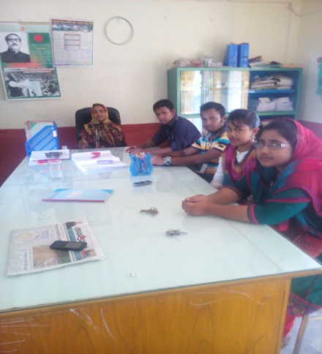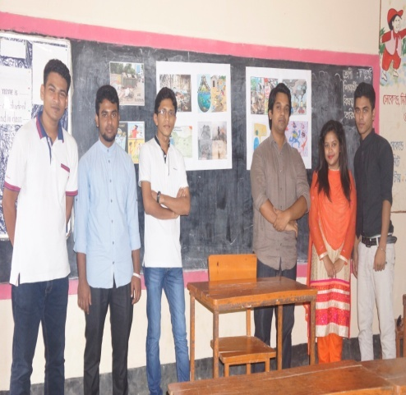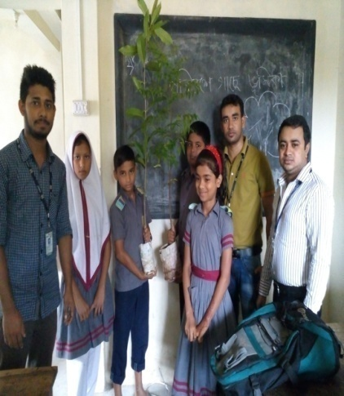

Figure 13: Students doing environmental campaign in Digda Govt. Primary School, Dhaka

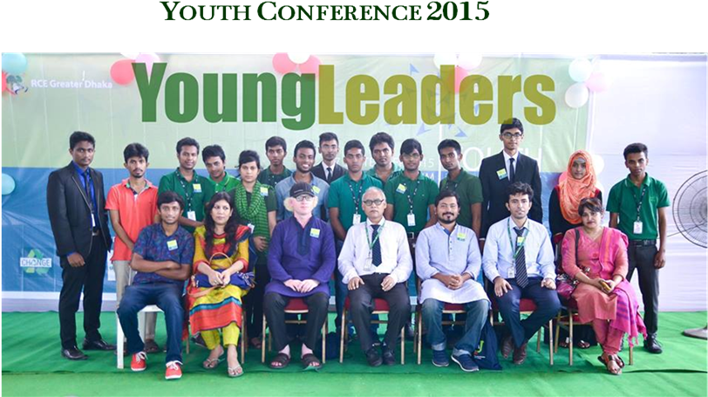
Figure 14: Youth Conference in RCE Greater Dhaka with promising youth leaders

Youth Forum:
Youth Forum, a student organization of RCE Greater Dhaka formed on 17th September, 2015 to operate all youth related activities for a sustainable world. It has been acting as a catalyst to accelerating sustainable activities viz. tree plantation, cleaning campaign, school outreach, community engagement and youth leadership for taking future challenges of the earth. This is a volunteer organization involving all faculty members of the Department of Environmental Science as advisors and funded by IUBAT University and local partners to train up youths for sustainable leadership.

Reference:

[1] http://www.rce-network.org/portal/

[2] http://www.rcegreaterdhaka.org/

[3] http://iubat.edu/

[4] Badsha, A. H. 2016 presentation on “Daily Water Consumption at IUBAT University and How to Reduce the Fresh Water Demand” in the Seminar on Industrial Wastewater Treatment System in the Context of Bangladesh, 20th March, 2016, held in IUBAT University.

[5] Dastagir M. R. 2015 presentation on “Education for Sustainable Development in IUBAT, Bangladesh”, 10th January, 2015. BAPA-BEN conference on "Environmental Policies and Acts Implementation Problems”, Dhaka.

