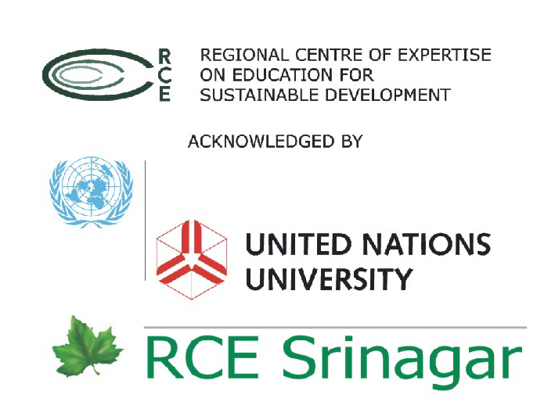


From Devastation to Recovery in Earthquake Hit Kashmir:
Linking Relief and Rehabilitation to Development

16-17 November 2011

On October 8 2011 we completed six years of the devastating earthquake that changed the face of Kashmir Valley throwing normal life out of gear. Reconstruction is nearing to end with most of the infrastructure in place barring a few remote schools or other such structures. Rehabilitation process thus after six years is in to a transition stage that leads to development. Success of relief and rehabilitation initiatives lies in enhanced capacities of individuals as well as the government.

Considering the earthquake vulnerability of the region, falling in Zone IV & V (highest risk zone), it becomes imperative that future development initiatives aim at mainstreaming Disaster Risk Reduction (DRR) into development with a view to reduce the vulnerability and minimise the probability of emergencies in future by creating more room for better safety nets, improved infrastructure, and secure livelihoods.

CEE Himalaya has remained part of this process since 2005 with its integrated earthquake response programme ‘Rebuilding Trust’. Implemented in 5 districts in Kashmir valley this programme focussed on restoration of education and introducing disaster risk reduction at school level; teachers’ capacity building and development of relevant IEC material in local language; strengthening livelihoods and popularising non-farm based alternate livelihoods; community based disaster preparedness through village level contingency planning.

A workshop ‘State of Recovery and Rehabilitation in Earthquake affected Jammu & Kashmir and the Future Strategies towards Resilience’ was organised by CEE and its partner Welthungerhilfe in October 2009. The workshop attracted deliberations on four thematic areas - Education, Health, Livelihood restoration, and Capacity building. The recommendations of the workshop highlighted:

- Need for strengthening school education both through structural measures as well as capacity building for DRR
- Strengthening primary health care infrastructure facilities and capacity building of primary and auxiliary health workers on emergency response
- Advocacy for conservation of local resources, strengthening traditional livelihoods and introduction of alternative income generation activities
- Strong networking mechanism for coordination of activities during emergencies
- Development of a public-private partnership for DRR
Programme ‘Rebuilding Trust’ is now in the phase out stage and CEE is looking forward to mainstream various initiatives undertaken during the programme. State of Jammu & Kashmir is already working on its DRR policy and number of initiatives being taken by the government towards disaster preparedness! Through this workshop scheduled on 16-17 November 2011 CEE and its partner Welthungerhilfe will try to establish linkages between various initiatives undertaken through the Rebuilding Trust programme with state initiatives.
Vision

Share and review the lessons learnt during recovery phase after the 2005 Earthquake. Bring national and local disaster management experts, government and other stakeholders together to discuss and plan strategies to mainstream disaster risk reduction in the further development process that provides sustainability to fragile and disaster prone ecosystems of Jammu and Kashmir.

Mainstreaming disaster preparedness into the development process entails an integrated approach involving different sectors. In addition to linking relief and rehabilitation to development and cross cutting themes, this workshop would touch upon following three sectors at length:
- education
- infrastructure
- coordinated response of government, non-governmental organisations and private sector
Workshop Outcomes

- guidelines for linking relief, rehabilitation to future development
- role clarity for disaster preparedness in different sectors
- networking, capacity building
- recommendations
Venue

Auditorium
Institute of Management, Public Administration and Rural Development (IMPA) , Srinagar, J&K

Participation

J&K Government concerned departments, NGOs, academicians and researchers, community representatives, village panchayat members, teachers, youth and media.

Tentative Programme Schedule

16.11.2011 WEDNESDAY

FORENOON
Registration
Welcome and Introduction to workshop
Keynote address
Guest lecture
Workshop expectations

TEA
SESSION - I
Safe Infrastructure – systems, building codes, skills/indigenous knowledge, resources and capacity development requirements

LUNCH

AFTERNOON
SESSION – I Continued
Safe Infrastructure – systems, building codes, skills/indigenous knowledge, resources and capacity development requirements

TEA
Screening of film/Release of Process Document ‘Rebuilding Trust’
17.11.2011 THURSDAY

FORENOON
SESSION - II
Education for Disaster Risk Reduction – Formal and non-formal interventions and school insurance

TEA
SESSION – II Continued
Education for Disaster Risk Reduction – Formal and non-formal interventions and school insurance

LUNCH

AFTERNOON
SESSION - III
Networking and Coordinated Response of Government and Non-Governmental Organisations

TEA
Recommendations - Future Plan of Action
Valedictory & Closing

For further details:

Ms. Sasmita Jena Dr. Abdhesh Kumar Gangwar
Project Coordinator Programme Director
Welthungerhilfe Centre for Environment Education (CEE)
Phone: +91-11-40520141 Phone +91-522-2716959
Mobile: +91-9810522279 Mobile: +91-9415104125
sasmita.jena@welthungerhilfe.de abdhesh.gangwar@ceeindia.org

