

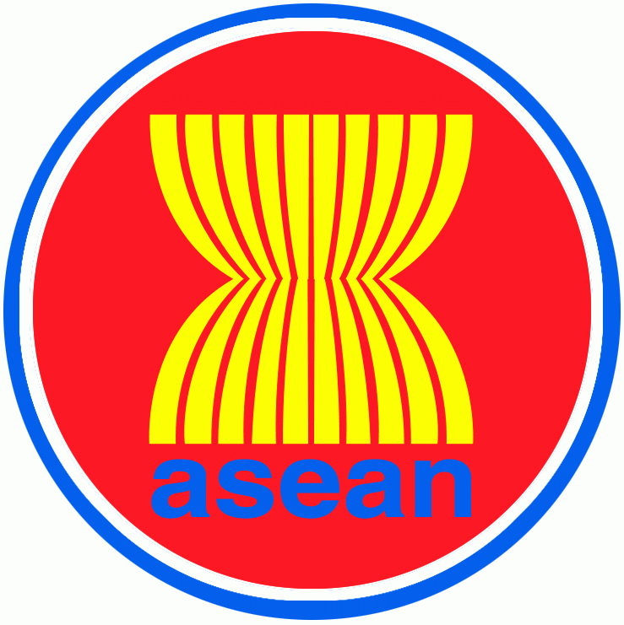
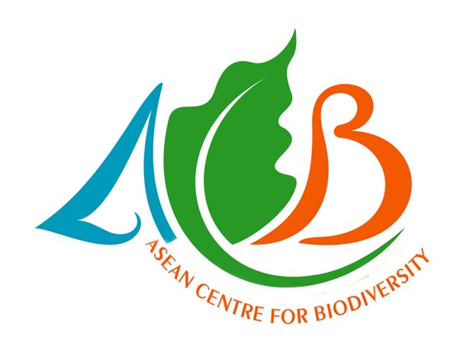

3rd ASEAN Plus Three Leadership Programme on Sustainable Production and Consumption

6-7 October 2010
Bayview Park Hotel, Roxas Boulevard, Manila Philippines

PROCEEDINGS
Technical Program

Day 1: 6th October

0830-0930: Session I

Welcome and Overview of Challenges, Issues and Practices
Chair: Department of Environment and Natural Resources
Atty. Juan Miguel Cuna
OIC-Director
Environmental Management Bureau-DENR

Opening Statements:

Usec. Demetrio Ignacio, Jr.
Chairperson, ASOEN-Philippines and Undersecretary for Planning and
Policy, Department of Environment and Natural Resources

Prof. Govindan Parayil
Vice Rector, United Nations University (UNU)
Director, UNU Institute of Advanced Studies

Dr. Raman Letchumanan
Head, Environment Division, ASEAN Socio-Cultural Community Department
ASEAN Secretariat

Mr. Rodrigo Fuentes
Executive Director,
ASEAN Centre for Biodiversity

Keynote - Overview, Challenges, Issues and Practices in Sustainable Production and Consumption: Global challenges; international commitments; hot issues for now and the future; businesses tackling risks and opportunities
- Prof. Govindan Parayil
United Nations University, Tokyo, Japan;
United Nations University Institute of Advanced Studies, Yokohama, Japan

A Primer on Leadership Skills: Leadership for sustainable development - concepts, processes and techniques; leadership and the change process; domains of leadership
- Prof. Mario Tabucanon
United Nations University Institute of Advanced Studies

0930-1000:

Opening of ASEAN Centre for Biodiversity Exhibition
Break

1000-1215: Session II

Consumption and Production Patterns and Approaches
Chair: United Nations University Institute of Advance Studies

Changing Consumption Patterns: Sustainable consumption as a major driver of sustainable development in Asia; quality of life, well being and happiness; ecological intelligence
- Dr. Peter King
Institute for Global Environmental Strategies, Bangkok Office

Reduce, Reuse, Recycle: 3R Knowledge Hub Initiatives in Waste Management"
- Mr. Masami Tsuji
Asian Development Bank

Eco-Design and Sustainable Manufacturing: Systematic integration of life cycle environmental considerations into product design and manufacturing to improve product performance and enhanced business value
- Prof. Anthony S.F. Chiu
Asia Pacific Roundtable for Sustainable Consumption and Production; De La
Salle University, Manila

Discussion

1215-1330 (Lunch Break)

1330-1700: Session III

Alternative Models of Development
Chair: ASEAN Secretariat

Green Economy: Vision of greener, cleaner, low-carbon and resource-efficient economies and societies; UNEP green economy initiatives
- Mr. Mahesh Pradhan (as delivered by Dr. Peter King)
United Nations Environment Programme Regional Office for Asia and the Pacific, Bangkok

Poverty Reduction: SPC helps reduce poverty and achieve sustainable development; reconciling these issues
- Dr. Zinaida Fadeeva (as delivered by Prof. Mario Tabucanon)
United Nations University Institute of Advanced Studies

Business and Biodiversity: Partnering with the business sector in finding solutions to biodiversity loss; business depending on biodiversity; corporations rely on plant and animal species and ecosystem services for their products
- Mr. Rodrigo Fuentes
ASEAN Centre for Biodiversity

(Break, 15 minutes)

Sufficiency Economy Philosophy: Viewing the philosophy as an approach to SPC – moderation, rationality, resilience, knowledge wisdom, and morality; Thailand experience in agriculture, government and business sectors
Prof. Mario Tabucanon
United Nations University Institute of Advanced Studies

Discussion

1830-2130

Welcome Dinner
- Hosted by UNU-IAS

Message
Dr. Francis Chua
President, Philippine Chamber of Commerce and Industry

Special Cultural Numbers from La Salle Filipiniana Dance Company

Day 2: 7th October

0900-1105: Session IV

CSR and Supply Chain
Chair: ASEAN Centre for Biodiversity

Corporate Social Responsibility in ASEAN: Incorporating the dimensions of sustainability – economic, environmental and social – in business planning and practice; key skills, strategies and tools that businesses and their managers need to adopt successful CSR programs
- Dr. Filemon Uriarte, Jr.
ASEAN Foundation

Sustainable Supply Chain and Logistics: Ensuring sustainable production practices of the entire supply chain and logistics; vendor evaluation and selection for sustainability using analytic hierarchy process
- Prof. Mario Tabucanon
United Nations University Institute of Advanced Studies

(Break, 15 minutes)

Discussion

1105-1120: Session V

Concluding Session
Co-Chair: UNU-IAS and DENR

Wrap-up and debriefing on Eco-site visit

1130-1230 (Lunch Break)

1245-1700

Field Visit to Unilever Philippines
Coordinator: DENR

‘Eco-site’ Visit (Unilever Philippines)

1900-2130

Farewell Dinner
- Hosted by the ASEAN Centre for Biodiversity

This was an intensive and highly participative program. Interaction among the resource persons and participants were aimed at maximizing the learning and sharing of experiences.

Post Leadership Programme Event

On 8th October 2010, the ASEAN Centre for Biodiversity organized a Business and Biodiversity Forum on “Business Opportunities in Biodiversity”. Participants and resource persons of the 3rd ASEAN+3 Leadership Programme on Sustainable Production and Consumption were cordially invited.

3rd ASEAN Plus Three Leadership Programme on Sustainable
Production and Consumption
6-7 October 2010
Bayview Park Hotel, Roxas Boulevard, Manila Philippines

Welcome Remarks
Atty. Juan Miguel T. Cuna
OIC-Director, Environmental Management Bureau- DENR

The hosting of the 3rd ASEAN Leadership Programme on Sustainable Production and Consumption (SPC) in the Philippines is very timely as it gives an opportunity and chance to be updated with the developments and different strategies employed by various ASEAN member-states, as well as Japan, Korea and China in terms of financial management and improved production.

This event is an opportunity also for the participants to learn about the different insights of the resource persons as they talk about the different papers showcasing issues and challenges of the implementation of sustainable consumption and production.

Message
Undersecretary Demetrio Ignacio, Jr.
Department of Environment and Natural Resources

This 3rd ASEAN Leadership Programme on Sustainable Production and Consumption aims to effectively address the continuous wanton destruction of our environment, as different solutions to preserve our natural resources are learnt.

Based on studies, there had been a tremendous increase of human population and in the Asia-Pacific Region, more than 680 million emerging as middle class have made lifestyle changes. Had it not for them, it is said that to be able to meet our resources needs, we need four to five additional planets to support our growing needs for goods and services.

We have already acknowledged the negative effects of climate change as more people have realized that the concept of sustainability must be integrated to ensure the companies thrive in today’s business environment.

Message
Prof. Govindan Parayil
Vice Rector, United Nations University (UNU)
Director, UNU Institute of Advanced Studies

The United Nations University Institute of Advanced Studies or UNU-IAS based in Yokohama, Japan, which is one of the institutes of UNU, feels privileged to be a participant in the process of developing the ASEAN Environmental Education Action Plan or known as ‘AEEAP 2008-2012’. Committed to be involved in its implementation, it has organized the ASEAN-Plus-Three Leadership Programmes on Sustainable Production and Consumption series, with the first two held respectively in 2008 and 2009, and this third one, in 2010 in Manila.
Appreciation was expressed by the UNU to the participants and the resource persons, and the organizations that they represent, namely – the ASEAN Foundation, Asian Development Bank, De La Salle University, Institute for Global Environmental Strategies, and the United Nations Environment Programme. He also thanked the Department of Environment and Natural Resources of the Philippines, the ASEAN Centre for Biodiversity, and the ASEAN Secretariat – for co-organizing the third run of the ASEAN-Plus-Three Leadership Programme on Sustainable Production and Consumption.

Message
Mr. Rodrigo Fuentes
Executive Director
ASEAN Centre for Biodiversity

Biodiversity is losing at an alarming rate, and one of the reasons pinpointed is humankind’s unsustainable patterns of production and consumption. Thus, the ASEAN Centre for Biodiversity regards the 3rd ASEAN Plus Three Leadership Programme on Sustainable Production and Consumption a critical step towards ensuring sustainable development amongst businesses and industries.

Just as businesses can impact on biodiversity, they also have the resources to conserve it. These sustainable production practices and strategies will be the main focus of the programme prepared by the Institute of Advanced Studies of the United Nations University, ASEAN Secretariat, and the Department of Environment and Natural Resources, to ensure that biodiversity – our life – is conserved.

Sustainable Production and Consumption: Overview of Challenges and Issues
Prof. Govindan Parayil
Vice Rector, United Nations University (UNU)
Director, UNU Institute of Advanced Studies

Global challenges for Sustainable Production and Consumption (SPC) ensue from a number of international commitments like the United Nations Conference on Environment and Development (1992), the Rio Declaration, Agenda 21 (1992), the World Summit on Sustainable Development (2002), the Marrakesh Process (2003), and the United Nations Decade of Education for Sustainable Development (2005-2014), among them.

All of these international commitments now recognize that current global patterns (policies and programs) of consumption are not sustainable. Socio-economic trends showcase more and faster consumptions while there is a decreasing flow of natural and economic capital. Natural habitat and species go extinct because of environmental deterioration (global warming and climate change) and resources usage goes down due to human population growth.

Challenges encourage changing consumption and use behavior, increasing resources-use efficiency and identification of new Sustainable Production and Consumption (SPC) models (systems) and improved technologies (Research and Development) while recurring issues like poverty, demography, public health and safety, environmental degradation, global warming , climate change persist.

To resolve these issues, there is a need to meet the challenges and redefine SPC in our lifestyles.

Leadership Skills: A Primer
Prof. Mario T. Tabucanon
Visiting Professor, United Nations University Institute of Advanced Studies; and Professor, Asian Institute of Technology

Leadership is the process of bringing the present state into a desired future state. It is the process of analyzing the past and the present (Learning), and designing a desired future (Visioning). Leaders play the transformative figures in this process of change. Leadership skills are not given, but they can be learned and developed. Developing leadership is not accomplished just by learning the theories; one must practice them. To be able to develop one’s leadership skills, it is important to know the domains of Leadership which are Personal, Relational, and Contextual.

Leadership should be seen as both a service and an obligation - an obligation to serve the organization for the common good. A good leader is a visionary and has the ability to anticipate future scenarios. He or she should have the ability to analyze options and make rational decisions and to understand different points of view. A good leader has the ability to generate enthusiasm among colleagues, and the willingness to accept responsibility and ability to communicate. He or she should possess flexibility and able to apply the right style at the right time and at the right situation.

Sustainable Consumption and Production
Dr. Peter King
Senior Policy Advisor, Institute for Global Environmental Strategies

Sustainable consumption is “the use of services and related products which respond to basic needs and bring a better quality of life while minimizing the use of natural resources and toxic materials as well as the emissions of waste and pollutants over the life-cycle so as not to jeopardize the needs of future generations.” Meanwhile, Sustainable production is “the creation of goods and services using processes and systems that are non-polluting, conserve energy and natural resources, are economically efficient, are safe and healthy for workers, communities, and consumers, and are socially and creatively rewarding for all working people.”
Sustainable consumption and production is “a holistic approach to minimizing environmental impacts and maximizing social benefits related to production and consumption.”

In conclusion, sustainable consumption must be driven by provision of information on products that compete with the global advertising budget of $400 billion per year. More aware consumers are already changing production behavior and more can be expected in future. The policy challenge is to create the enabling conditions for more sustainable consumption and production (e.g. through green procurement) and then monitor and learn from how production changes in response. Changes in consumption preferences alone will not drive structural change in the socio-economy. Unsustainable production must be penalized, consumer choices must be widened, and governments can lead the way.

Reduce, Reuse, Recycle: 3R Knowledge Hub Initiatives in Waste Management
Mr. Masami Tsuji
Principal Environment Specialist, Asian Development Bank

The vision of Asian Development Bank (ADB) is an Asia and Pacific region free of poverty. To achieve this goal, ADB’s Long-Term Strategic Framework for 2008–2020 lies in three Strategic Agenda namely: Inclusive Growth, Environmentally and Sustainable Growth, and Regional Integration and Cooperation.

Waste management process an important integral part of the projects being funded by ADB. Projects of the ADB in waste management in the Asia-Pacific Region have centered on waste to energy, landfills and composting projects. For cities among these are centered on Waste management project development in medium and small towns, Studies on policy, technology and knowledge barriers in 3R applications, and Development of large-scale waste management projects to facilitate private sector participation.

Meanwhile for industries, projects include: Resource recovery firms (collection, processing, reuse, remanufacturing); Renewable energy and energy efficiency firms (solar, wind, biomass gas and fuel, geothermal); Biomass production and processing (bio-energy and bio-products); Wastewater reuse for agricultural and urban uses; Sustainable farming support companies; Green chemistry and nanotechnology companies and institutes.

The 3Rs lie at the heart of any effort to achieve resource efficiency. As such, it is important to should reduce resources and wastes generated throughout the life cycle of products and services; reuse products and waste materials (including production of by-products) independently or as inputs to other production processes; and recycle wastes into a form suitable for use as an input to production.

Life Cycle Thinking as a Green Competitive Strategy
Prof. Anthony S.F. Chiu
Chair, Asia Pacific Roundtable for Sustainable Consumption and Production; Professor, De La Salle University

Life Cycle Thinking is a paradigm that provides a holistic picture of an entire product system including resources extraction, material processing, transportation, manufacturing, distribution, use, disposal and reuse and recycling.

By definition, a product is that which provides benefit for a user. It provides service and utility function, leading to the generation of value to the user. Thus, the focus on making a product relies on covering the user’s needs. Service can be provided in many ways. Providing environmental assessment of products is one form assuring the user that environmental considerations were made in the making of the product, thus making it more serviceable to users.

The process of Environmental Assessment of a Product is used to define and quantify the service provided by the product (utility function), to identify and to quantify the environmental exchanges caused by the way in which the service is provided, and to ascribe these exchanges and their potential impacts to the service.

Among the assessed impact parameters are: global warming, stratospheric ozone depletion, photochemical ozone formation, acidification nutrient enrichment, ecotoxicity, human toxicity , resource consumption and working environment.

If a product undergoes environmental assessment, environmental considerations can enter the chain of supply and demand and be a parameter of competition on equal footing with other parameters for the product such as price and quality.

Green Economy: Vision of greener, cleaner, low-carbon and resource-efficient economies and societies; UNEP green economy initiatives
Mr. Mahesh Pradhan (as delivered by Dr. Peter King, IGES)
United Nations Environment Programme Regional Office for Asia and the Pacific, Bangkok

The conditions of the economy and environment at the global context – the multiple crises on financial, fuel, food, ecosystem and climate; and emerging opportunities such as the stimulus packages, the global collective rethinking and the transition to a green economy had been presented. The shift towards sustainable consumption and production, resource efficiency, and green economy through policy reforms, culture of change and relevant tools necessary to change behavioral consumption styles were likewise presented.

The Green Economy was also discussed, its goals and how it relates to other initiatives such as Resource Efficiency and Sustainable Consumption and Production; The benefits of Green Economy to developing countries, and the driving actions had also been mentioned. Finally, the UNEP Green Economy Initiative, its key messages and components, The Economics of Ecosystems and Biodiversity, the Green Jobs Report, and the Green Economy Report; and the Green New Deal, had all been discussed towards a Green Movement.

Sustainable Production and Consumption – working with poor
Dr. Zinaida Fadeeva (as delivered by Prof. Mario Tabucanon, UNU-IAS)
United Nations University Institute of Advanced Studies

A famous quote from Kofi Annan, former Secretary-General of the United Nations, establishes the importance of the businesses in poverty alleviation: “It is the absence of broad-based business activity, not its presence, that condemns much of humanity to suffering. Indeed, what is utopian is the notion that poverty can be overcome without the active engagement of business.” In support of this, the adoption of the Millennium Development Goals (MDGs) has defined the direction towards significantly reducing or eradicating poverty by the year 2015. Businesses are expected to contribute to achieving these goals. However, there are ongoing debates in terms of the provision of products and services. Some questions posted include: Are the products and services marketed to the poor the most urgent and essential? What development is being promoted by marketing products to poor communities? Does granting access to a product lead to sustainable development?

The Base of the Pyramid (BoP) Protocol engages in deep listening and mutual dialogue with income-poor communities; co-discovers and co-creates new business opportunities and business models embedded in the local cultural infrastructure; and co-designs and launches BoP businesses that generate mutual value for all partners. Pro-poor business means inclusive business, business for the bottom of the pyramid, business with the base of the pyramid, and sustainable livelihood business. Core business contributes to achieving sustainable development by defining the roles of business: provision of products and services, sourcing locally, and getting local communities involved. Notable examples include the complementing initiatives of Procter and Gamble, Holcim, Cemex, and SC Johnson.

Throughout history, a number of contributing movements and processes evolved: the Cooperatives Movement, fair trade, microenterprises (microfinancing), social firm (employment of socially disadvantaged), Bottom of the Pyramid Protocol, funding by international organizations, and collaboration between developmental organizations and entrepreneurs. Recent movements promote social enterprise– defined as “any business venture created for a social purpose, i.e. mitigating/reducing a social problem or market failure”. The goals of social enterprise underscore the significance of social and economic values. It operates through a different degree of mixing of social programs and business activities.

Sufficiency Economy Philosophy: Viewing the philosophy as an approach to SPC – moderation, rationality, resilience, knowledge wisdom, and morality; Thailand experience in agriculture, government and business sectors
Prof. Mario T. Tabucanon
United Nations University Institute of Advanced Studies

A background presentation is made about the Sufficiency Economy Philosophy (SEP) developed by His Majesty, the King of Thailand; its main components and application as a model for sustainable development in Thailand. Accordingly, Sufficiency Economy is a philosophy that stresses the middle path as an overriding principle for appropriate conduct at all levels of society – individual, household, community, organization, or government.

As a philosophy, the comparison of SEP to neoclassical economics is presented including the misconception about the SEP. The presentation on SEP application focuses mainly on its use to 1) daily life through moderation, reasonableness and self-immunity; and 2) economic development through agricultural/community development, business practices and government policies. A case presentation of business practices and government policies adopting SEP, its outcomes and implications to business and government is given; and finally, a presentation of SEP is made as an approach to sustainable development.

Business and Biodiversity: Partnering with the business sector in finding solutions to biodiversity loss; business depending on biodiversity; corporation rely on plant and animal species and ecosystem services for their products
Mr. Rodrigo Fuentes
Executive Director, ASEAN Centre for Biodiversity

Biodiversity affects more than 500 million people in the region. The 10 countries comprising the ASEAN Member States (AMS) have elaborated the importance of the biological resources specifically the coral reefs, the Coral Triangle Initiative and the terrestrial portions of biodiversity especially the Heart of Borneo that covers three of the 10 AMS namely: Brunei Darussalam, Indonesia and Malaysia.

Biodiversity and Business delve into the Business and Biodiversity Initiative of the Convention on Biological Diversity. It explains the various initiatives of large business corporations who are signatory to the Convention. Partnerships between business corporations and with the ASEAN Centre for Biodiversity are explored and some areas of collaboration are already identified and some have been proposed to support this endeavor. There are several activities and other initiatives of the ACB that are currently on-going in South East Asia regarding business and biodiversity.

Corporate Social Responsibility and Sustainability in ASEAN
Dr. Filemon A. Uriarte, Jr.
Executive Director, ASEAN Foundation

True to the ASEAN mission to ensure that Corporate Social Responsibility (CSR) is incorporated in the corporate agenda and to contribute towards sustainable socio-economic development in ASEAN Member States, the CSR ASEAN: A Network of CSR Practitioners in ASEAN Countries is introduced. This serves as a platform for network and exchange at the regional level, including the capacity building and advocacy for CSR, to engage the private sector to support the activities of sectoral bodies and the ASEAN Foundation, in the field of corporate social responsibility.

The importance of CSR and its relation to various aspects of Sustainable Development, as follows , are highlighted : (CSR is an entry point for understanding SD issues); Globalization (CSR plays vital role in detecting steps to maintain and build the public good), Governance (CSR often reflects goals on human rights and the environment), Corporate Sector Impact (Companies being global ambassadors of change and values); Communications (CSR leads to partnerships), Finance (a sound CSR approach can ensure better responsiveness to markets); Ethics (CSR can improve corporate governance and ethical standards), Consistency and Community (CSR builds a sense of community); Leadership (CSR can offer flexibility and incentives), and Business Tool (CSR enhances brand and company reputation). Steps are also identified for CSR integration: ensuring the commitment of top management; the appointment of a CSR position at the strategic decision-making level; and the development of relationships with all stakeholders and interest groups.

ASEAN was established on 08 August 1967 in Bangkok by five countries: Indonesia, Malaysia, Philippines, Singapore and Thailand. Brunei joined in 1984, Vietnam in 1995, Lao PDR and Myanmar in 1997 and Cambodia in 1999. The ASEAN Charter was adopted during the Singapore Summit in 2007 to serve as the legal and institutional framework of the ASEAN.

The ASEAN Foundation aims to help bring about shared prosperity and sustainable future for the entire ASEAN region. The mandate of the ASEAN Foundation (which is found in Article 15 of the ASEAN Charter) is to support the ASEAN community-building by promoting greater awareness of the ASEAN identity, people-to-people interaction, and close collaboration among the business sector, civil society, academe, and other stakeholders of ASEAN.

Sustainable Supply Chain and Logistics
Prof. Mario T. Tabucanon
Visiting Professor, United Nations University Institute of Advanced Studies;
Professor, Asian Institute of Technology

Uncertainties in the supply chain demand a shift from Supply Chain ‘Profitability’ to ‘Sustainability’ – which should be measured in terms not of profitability, but of sustainability (taking into account economic, environmental, and social considerations). Sustainable Production among enterprises is therefore entailed. To do this, sustainability issues must be integrated in the decision-making phases (planning and operation).

Vendor (Supplier) Selection Problem (VSP) and Green Procurement are introduced. VSP takes on the selection of the right vendors according to the sustainability criteria whereas Green Procurement, on the other hand, takes into account environmental elements in the acquisition of goods and services. International standards should also be considered – ISO 14000 Series for environmental management; Social Criteria Standard for social responsibility; and the SA 8000 Standard for economic concerns. The following methodology is presented to guide businesses towards Sustainable Supply Chain: 1) Develop evaluation hierarchy for new model; 2) Use Model (AHP) for ranking all criteria and vendors in each context -- economic, environment, social; 3) Find Champion in each context; 4) Develop Ideal Sustainability Vendor (ISV); and 5) Use Model (DEA) to find efficiency of vendors compare with ISV.

Sessions I and II: Open Forum Documentation

Question: We would like to hear from you what businesses should do to curb climate change.

Answer (Peter King):

We have to be progressive to be partners of sustainable development. To curb climate change we should change our outlook—the way we consume products that would reduce our impacts on the environment. Integrate today’s learning in all your activities in your business. Take Actions.

Question: How does Japan use its recycled materials?

Answer (Anthony SF Chiu and Masami Tsuji):

Ecotowns are characterized by efficient use of recycled materials. In Japan, there are many eco-towns built, but the two most successful are the Kawazaki and Kitakyushu ecotowns. In using recycled materials, they do several studies like research and development of appropriate technology. They pilot test the technology on a certain product and then commercialization of the said product. So far, these two eco-towns have been generating good returns to the country. The Kawazaki and Kitakyushu ecotown involves recycling of paper and P.E.T. bottles.

Question (AIM) : Your lectures have focused more on encouraging people or wanting always people to stop using and/or consuming a particular product that you deem unsustainable. But it seems I have not heard any discussion on neoclassical consumption.

Answer: (Mario Tabucanon and Peter King)

There had been some attempt in focusing discussions on the different economic models in this seminar. There is a good book published by a good friend of mine on economics which shows new economic values and paradigms. But, old theories and new upcoming models sometimes confuse economists and learners on appropriate economic models to use in coming up with sustainable consumption models. But nevertheless, what we are trying to say is, study the different models, such as classroom models, compare them and apply what is appropriate to your businesses.

Session III: Open Forum Documentation
Green Economy
by Peter King for Mahesh Pradhan
Question: (Ella) Has there been discussions on environmental governance in different fora?
Answer: (Peter) Yes, there are.
Question: (Ella) What about the idea of organizing/creating a regional organization like the EEA?
Answer: (Peter) That would be quite interesting. There are discussions also about international financing mechanisms, as well as on the harmonization of Multilateral Environmental Agreements. Initially, the chemicals cluster are currently taking this issue up, and the next round will be on biodiversity-related conventions such as the CBD, CITES, and Ramsar.
Question: (Masami) I would like to raise two issues: first, is the difficulty in achieving the MDGs, that is why people think that UNDP is weak; and second, is the not so successful discussion on climate change. There are issues/reasons to strengthen the governance agencies especially when there are duplications in addressing biodiversity-related issues.
Question: (Raman) Rio+20 should have met these, but there seems to be no “excitement” on this. Perhaps this is because information about Rio+20 is still sketchy. Institution building is difficult especially since there are a lot of institutions.
Question: (Peter) One of the principles to think about is that “form follows function”. We should be mindful, “what are the current functions that are really needed?” Institutions should focus more on conserving the environment at the national and sub-national levels then at the global level. There are not many institutions in place for adaptation.
Question: (Raman) There are enough global organizations. There is a need to strengthen regional institutions. We would like to ask: where is the press? Where are the NGOs? Why are they not so gung-ho about the Rio+20?
Question: (National Press Club) There is lack of information and more information dissemination should be done. I would like to ask: how can we help you?
Question: (Ella) There is a need to go more local than global. Every time there is a convention, another body is created without coordination. There should be more information dissemination and good governance.
Question: (Peter) It should be proposed to have a five-year moratorium on international meetings for at least five years. For example, in Tuvalu, only five people in their environment agency spend more than 100 days a year attending global meetings.

Sustainable Production and Consumption: Working with poor
by Mario Tabucanon for Zinaida Fadeeva
Question: (Raman) The old paradigm is to provide social services to the poor. But, the new paradigm is to involve the poor in SPC.
Question: (Bayani) This is about social support systems. In advanced countries, the government provides but in less developed countries like the Philippines, they do not have enough funds. What is the best model for the Philippines to help the poor?
Answer: (Mario) The example is business going straight to the poor; involve more businesses with the poor. No need to wait for the government; directly engage or approach the poor.
Answer: (Raman) There are many models to choose from.
Question: (Ella) Whatever civil society would do, the policy environment should still be there. There is a need for social entrepreneurs/agents. An example is the “rags to riches” project wherein Ateneo helped poor people in the rags business. Businesses can do something, but we must develop social entrepreneurs.
Answer: (National Press Club) Gawad Kalinga is a good model. It is a self-help program that is into transforming values.
Answer: (Mario) UP Cebu gave an example of CSR of a group of companies. A dozen companies worked together in CSR in engaging the poor.
Question: (Lawrence) Business of SM does not have by-products; manufacturing companies have by-products that the poor can benefit from. Which model can we use among those presented?
Answer: (Elen) SM has the reusable bags campaign.
Answer: (Raman) SM can generate revenues from the sale of these bags. SM has a bigger role. Like government, SM can set own policies which they listen to.

Finding Solutions to Biodiversity Loss: Business and Biodiversity
by Rodrigo Fuentes
Question: (Raman) How can business can adopt an ASEAN Heritage Park.
Question: (Peter) I would like to share the experience of Viet Nam on payments for ecosystem services (PES). Watershed revenues (1%) go into funds that go back to the stewards of the watershed.
Question: (one company) Aside from getting good company image, what are the incentives for businesses when partnering in biodiversity projects?
Answer: (Rod) Companies like HSBC get mileage in promoting biodiversity activities. Industries should be more familiarized with the concept of biodiversity.
Question: (Ella) Based on my involvement with a study on megatrends, the rate of use of resources is very fast. Is there a strategy in ASEAN or how can ASEAN work together to temper the export of natural resources to China? Even slow it down?
Answer: (Raman) That is an interesting question. How do you solve the problem? If you slow down China, you slow down ASEAN.
Question: (business man) “Parks”/malls are changing the culture of the younger generation.
Answer: (Rod) We need to clarify what “park” refers to: if it is a national or natural park, or otherwise.
Answer: (Raman) A park is the responsibility of the government. At the national level, these parks can easily be degazetted. ASEAN Heritage Parks (AHP) bring pride to the country. Three big corporations can adopt an AHP to boost their images.
Question: (old man) We should promote biodiversity through a policy like specific to economic zones.
Answer: (Cristi) In the Philippines, we have the National Integrated Protected Areas System (NIPAS) Act.
Question: (young man) What is the rate of biodiversity loss?
Answer: (Rod) Each ecosystem has its own rate of degradation. Based on the Millennium Ecosystem Assessment, extinction rate is a thousand-fold now during the present century as compared to previous generations. There is a need to invest more on what we need to know.
Answer: (Raman) Look at the ASOER4 (4th ASEAN State of the Environment Report). ASEAN has the highest deforestation rate in the world (1.1%). World deforestation rate is about 0.1%.
Answer: (Rod) Get hold of ASOER4 and GBO3 (Global Biodiversity Outlook 3). GBO3 talks about threshold levels and tipping points.

Sufficiency Economy Principle: A Model for Sustainable Development
by Mario Tabucanon

Question: (Elen) What are the indicators of success? How can governments leapfrog the application of SEP?
Answer: (Mario) The King of Thailand stressed that SEP should be fundamental in the national plans. Application of SEP in the rural areas has a good success rate. You have to input moderation, reasonableness and resilience.
Answer: (Raman) SEP works in Thailand because of the King. Other countries can do it but it would be difficult.
Question: (Masami) What is the limitation of this philosophy?
Answer: (Mario) Politics should not be an impediment to the application of SEP.
Question: Can SEP be adopted in the Philippines?
Answer: (Mario) The King has been very effective in convincing the people to adopt SEP because he showed a lot of real successful case studies. If you can translate it into science, then it is a good thing. The King demonstrated leadership by example; politicians do not show results. Following SEP, we need to change the way we do things.
Question: (business man) Knowledge and skills of Filipinos are at par with other cultures of the world; governance is the problem.
Question: (young man) SEP is anchored on Buddhism. Belief of the people to the King is present.

Session IV
CSR and Supply Chain
Question (from Miss Elenida Basug, Chief, EMB-EEID):
If there is an Environmental Office in a company, can it be already considered as CSR?

Answer: It depends on who you are talking with as there are a lot of aspects that can be considered as CSR (i.e. human rights, etc.). In the Philippines, there are three predominant CSR concerns – education (as in the case of Metro Bank), health, and environment, with the latter being at the forefront of late. However, in the West, this is insufficient as CSR should be incorporated in each step of the supply chain. Environment, therefore, is important, but it is only a component.

Question (from Mr. Tony Rosales, NGO, Trimedia):

What are the important matters that need to be addressed in CSR?

Answer: Civil Society is not only an important factor in CSR, but is also essential. Without civil society, who acts as a watchdog, the practice of CSR would not be as widespread. This is important given the fact that in the latest ISO 26000, CSR is the way by which corporations could help attain sustainable development.

Question: How are profits made?

Answer: Profits are realized through this equation:

Revenue (minus) Economic Cost (minus) Environment Cost (minus) Social Cost (plus/minus) Investment on Environmental Social Activities (equals) Profit

How people look at the company CSR should also be considered. This includes strengthening peoples’ belief on CSR, and how they can enjoy it. Profit should be on the right side of the margin, and Peoples’ Acceptance/Enjoyment on the left, to come up with a margin for Sustainability Development.

Question (from Dr. Pollisco of ACB):

Answer: There is a notion that CSR’s only role is to make a company look good. What are the other benefits of CSR?

Utilize CSR as a means to make a corporation viable (particularly true in extractive industries). There is a mining company that initiated about five years of CSR in the community before going full-blast in its operation. This increases acceptability of the company in the locale.

Sustainable Supply Chain and Logistics: Ensuring sustainable production practices of the entire supply chain and logistics; vendor evaluation and selection for sustainability using analytic hierarchy process
Dr. Mario Tabucanon
United Nations University Institute of Advanced Studies

Question (from Miss Elenida Basug, Chief, EMB-EEID):

To what extent can the economic-environmental-social model be integrated into the ASEAN Corporate Social Responsibility program?

Answer: The Model is neutral and can be used in any way, depending on the user. If used in the ASEAN, it will adopt the ASEAN ranking – and will use the ASEAN benchmark.

Question (from Dr. Filemon Uriarte, Jr.):

How sensitive are the figures in the model?

Answer: Analyze the best amidst hundreds of vendors; this is with the assumption that these are expert assessment numbers. The vendor selection example can also be applied in other companies. The Model can also be used to determine company growth and performance, with, instead of “vendors”, “years” could be replaced as variable.

Prof. Parayil noted that “variability among the best companies is very limited, hence the figures”

Session IV: Open Forum Documentation
Session IV, Presentation 1
- Comment: The usual connotation of CSR is the top of the pyramid – philanthropic and ethical. But it is more than that.

- Question: Is having an Environmental Office in a company enough as CSR?

Answer: CSR is broader; environment is just a part of CSR. Human rights are already incorporated in CSR. Traditionally, in the Philippines, there are two areas of focus – education and health and environment (biodiversity). Example: Metrobank – education; also PHINMA. Ayala – environment. But CSR must be incorporated in the supply chain to determine if they are consistent with ethical practices, etc. Environment is as important but is now only a component

- Question: CSR is integrated into an association that it seems that the mandate is decided by a small group. What is the criterion? I think it should be the money that should be poured in?

Answer: The traditional CSR is that the CSR is taken from profits. Therefore, one has to be profitable first before you can do CSR. The new thinking in CSR is that CSR is not your activities taken from your profit but CSR is about how you made that profit.

- Insight: Reiteration of an earlier example on a Canadian mining company operating in the Philippines which did CSR first before starting operations. There a number of companies that is CSR.

- Question: UNU – We need a strong civil society and media to push companies to do CSR.

Answer: Civil society is a prime mover with regard to compliance with CSR practices. But there are companies that are, by themselves, concerned/inclined towards protecting the environment.

- On SD and CSR: The final definition of ISO 26000 as per draft, is to link CSR to SD. CSR is the way by which corporations can help SD. (Issue: The draft final definition of CSR is to link it to sustainable development.)

- Question: (Dr. Mario Tabucanon): Regarding how profit is made, we have to change the profit equation to read: Revenue – (economic cost+ social cost+ environmental cost) = Profit
Answer: 2 dimensions: Inward CSR: addressing to employees, looking outside the box, human resources enjoying the CSR by engaging the community.
- Insights: Thailand – Petrochemical company – first, its activity was just philanthropic approach - rehabilitation of 600 hectares of fishpond. Now, it is functioning as an eco-tourism destination. In Indonesia, a mines tailings pond converted into a wetland. Now, it is eco-tourism. In Cebu, an area is a marine sanctuary for tourist for recreation and education, and now it is earning.

Session IV, Presentation2: Sustainable Supply Chain and Logistics
- Bottomline: Do not merely apply CSR within one’s company, but apply it in the whole supply chain.

Answer: These could be integrated into the CSR and they can tell or give indications to the ASEAN Foundation.

- Question: (Dr. Uriarte): How sensitive are the numbers in the example? What is the significant number? (with reference to the example). The CEO should be asked how to put weight, e.g., on environment.

Answer: (Dr. Tabucanon): These are the top seven of the 200 vendors. One application is vendor selection.

Other applications of the vendor selection system: Another application is the Sime company that has six business lines. It could also be applied to one company to determine performance over a period of time such as annual performance.

- Question: (Dr. Uriarte): In the individual parameter, we assume that numbers are expert assessment. And we assume that there will be two or more experts.

Answer: Yes.

- Question: (UNU): The big picture is to give impact and efficiency. There should have been more variability (in the examples) for better understanding because it is a useful benchmarking.

- Question to Dr. Uriarte: If one company goes into CSR, are there other incentives that they will get from this?

Answer: The biggest incentive is still image. We cannot dispute that. But that is changing. That is why CSR is now being imbedded into the supply or value chain. You can utilize CSR by which you can make your company viable. This is true particularly in extractive industries. CSR can be integrated into the operations of the company, that it is part the vision and mission. In the case of Asia, there are few takers of the UN Global Principle. It might be due to lack of information.

CONCLUDING SESSION: Messages from the Resource Persons
- Dr. Raman briefed the group on the ASEAN Environmental Education Action Plan (AEEAP). The Action Plan started with the three ASEAN Communities. The ASCC has a range of subjects – education, S&T, environment, etc. Under Environment is environmental education that has an Action Plan. 2008-2012 is the second part of the AEEAP. Its development was strategic, very focused. This is the first time to bring together education and environment. When the AEEAP was drafted, participants were composed of one from the education and one from the environment - which was a real problem at first. First, the group focused on formal, informal, capacity-building. So, there was harmonization of guidelines in terms of proposing model curriculum. It is also working on the industrial sector. There is a need to train business students on environment. On the informal side, ASEAN organized the youth in Brunei. This Leadership Programme is also one of the focuses of the AEEAP.

Dr. Raman informed the group about statistics and data on environmental education and best practices that can be found in the ASEAN inventory database. He mentioned about the collaboration of the military, religious groups and other sectors. He advised especially the media to go the website.

The ASEAN environmental ministers will be meeting in October 2010, and the ASEAN Secretariat will report on these activities. This is an effort by all of us.

- Prof. Parayil stated that UNU is privileged to be a partner in this activity – how it can create curricula to change outlook on the way we behave and consume products and how we produce impact on the environment. He expressed the hope that the two-day activity would help the participants to imbibe the learnings from this leadership programme. But we need partners – UNU needs to hear from the participants about their experiences and ideas about the various issues that they are confronted with. He encouraged the participants to communicate with the UNU, the ASEAN Foundation and the ASEAN Secretariat for inputs.

- Prof. Mario Tabucanon stated that the UNU-IAS is taking the lead in the leadership training programmes organized under the ASEAN Environmental Education Action Plan (AEEAP 2008-2012), and thanked the ACB, the DENR, the UNU and the ASEAN Secretariat. He mentioned about collaborations among various organizations, and concluded that actions should be taken by identifying issues. Prof. Tabucanon also thanked IGES, UNEP, De La Salle, ADB and colleagues in UNU, as well as others who have made the programme possible. He thanked all partners and will call on them in future programmes.

- Ms. Elen Basug - On behalf of DENR Undersecretary Ignacio and EMB Director Cuna, she thanked principal partners, UNU, ASEAN Secretariat, ACB for the collaboration on the entire program. She also thanked the participants and all partners. She expressed hope that the learnings will propel into actions for the application of CSR in the Philippine business and the ASEAN as a whole.

- Mr. Rey Molina informed and invited the participants to the dinner that ACB is hosting. He also invited participants to the ACB-sponsored seminar on Business Opportunities in Biodiversity, on 08 October 2010.

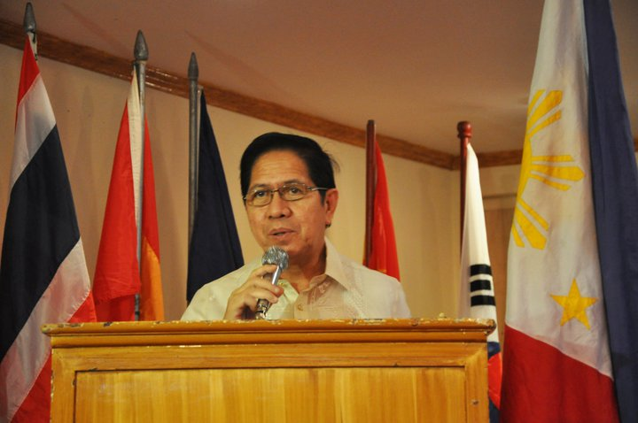

Welcome Statement by Usec. Demetrio Ignacio, Jr., Chairperson, ASOEN-Philippines and Undersecretary for Planning and Policy, Department of Environment and Natural Resources

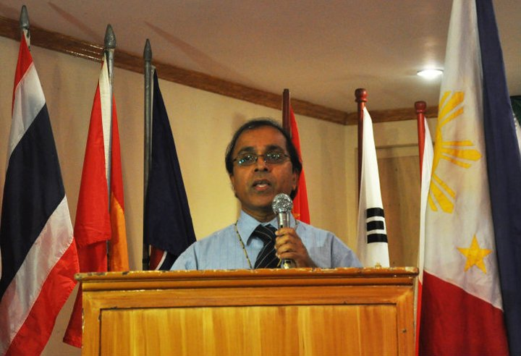

Opening Statement by Prof. Govindan Parayil, Vice Rector, United Nations University; and Director, United Nations University Institute of Advanced Studies

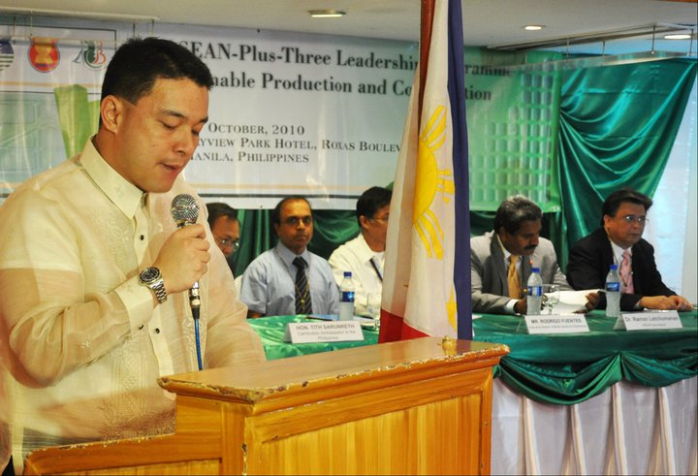

Session One Chair delivering the Opening Message: Atty. Juan Miguel Cuna, OIC-Director
Environmental Management Bureau-DENR

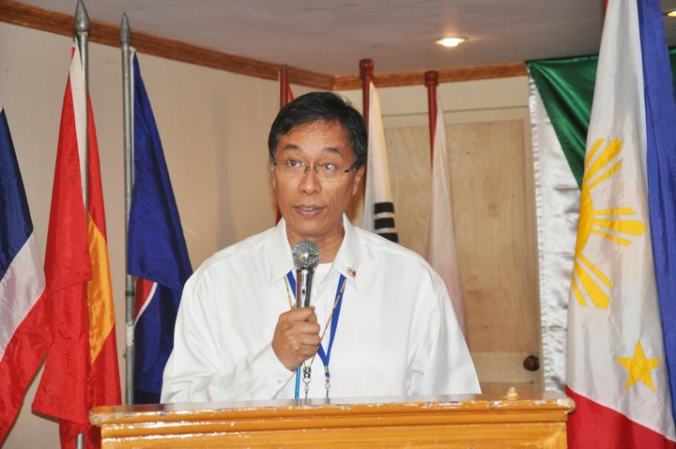

Opening Statement by Mr. Rodrigo Fuentes, Executive Director, ASEAN Centre for Biodiversity

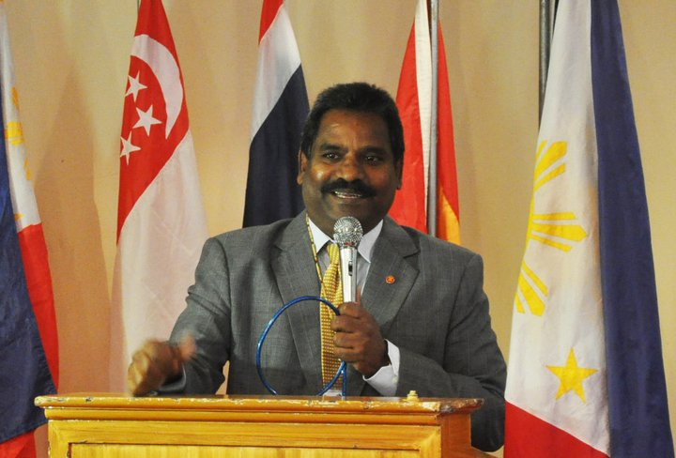

Opening Statement by Dr. Raman Letchumanan, Head, Environment Division, ASEAN Socio-Cultural Community Department, ASEAN Secretariat

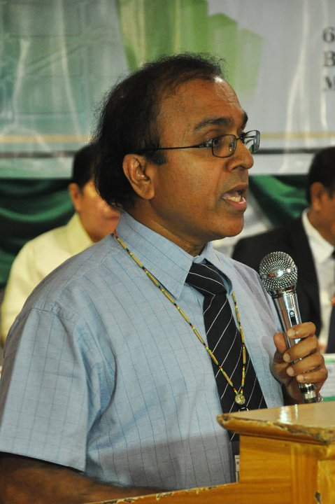

Keynote - Overview, Challenges, Issues and Practices in Sustainable Production and Consumption: Global challenges; international commitments; hot issues for now and the future; businesses tackling risks and opportunities by Prof. Govindan Parayil of the United Nations University
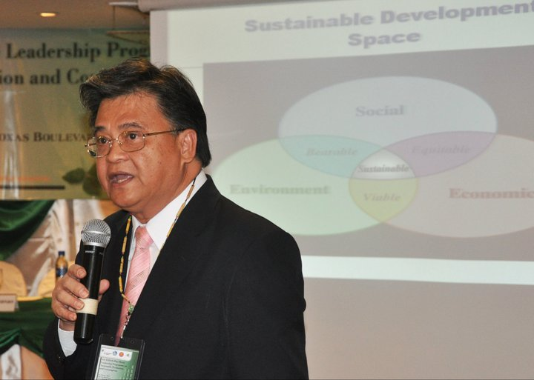

A Primer on Leadership Skills: Leadership for sustainable development - concepts, processes and techniques; leadership and the change process; domains of leadership by Prof. Mario Tabucanon of the United Nations University Institute of Advanced Studies

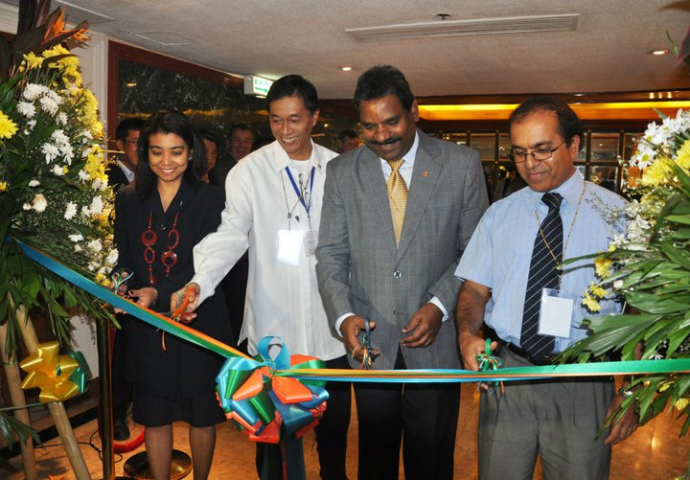

Opening of the ASEAN Centre for Biodiversity Exhibition

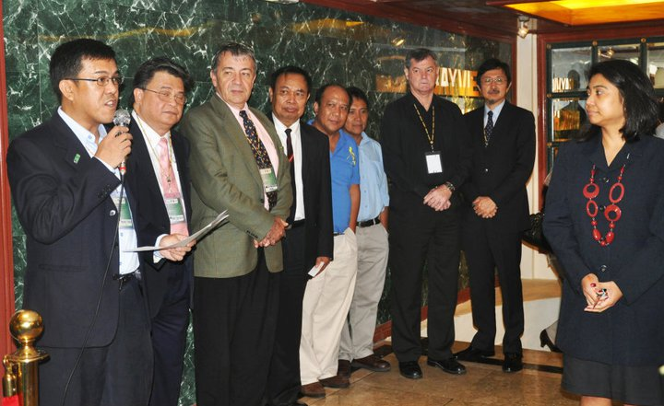

Opening Ceremony for the ASEAN Centre for Biodiversity Exhibition

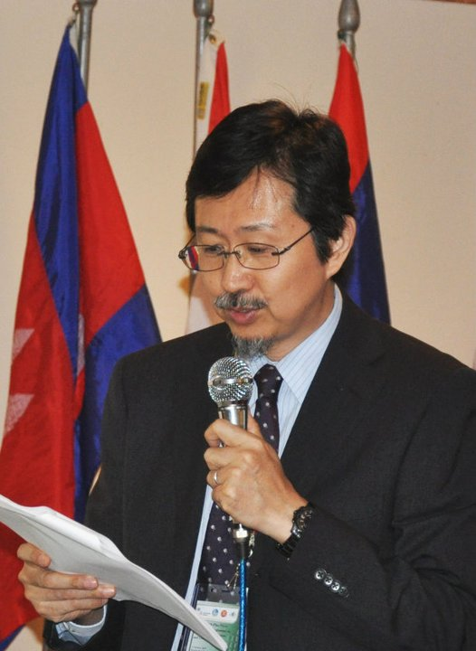

Reduce, Reuse, Recycle: 3R Knowledge Hub Initiatives in Waste Management"
Masami Tsuji, Asian Development Bank
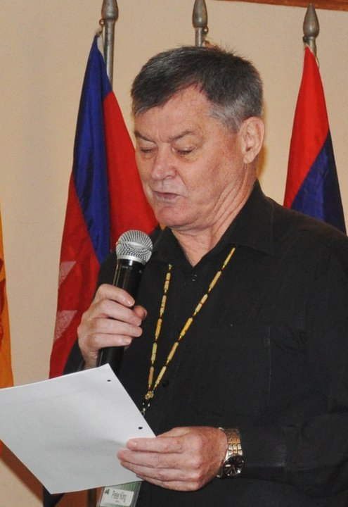

Changing Consumption Patterns: Sustainable consumption as a major driver of sustainable development in Asia; quality of life, well being and happiness; ecological intelligence by Peter King of the Institute for Global Environmental Strategies, Bangkok Office

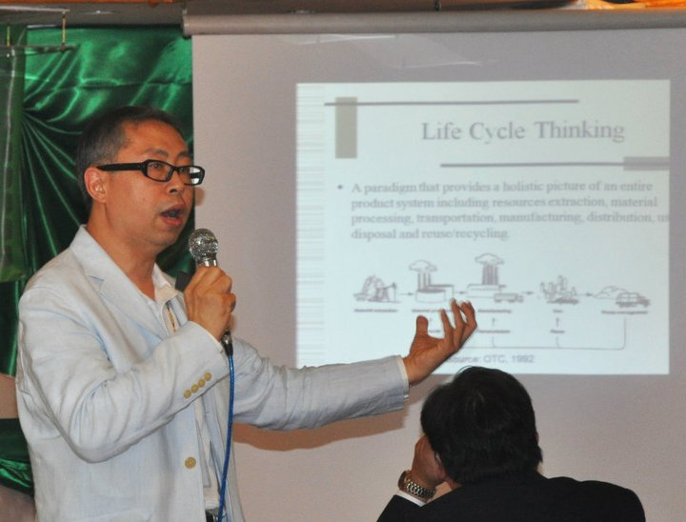

Eco-Design and Sustainable Manufacturing: Systematic integration of life cycle environmental considerations into product design and manufacturing to improve product performance and enhanced business value by Anthony S.F. Chiu of the Asia Pacific Roundtable for Sustainable Consumption and Production; De La Salle University, Manila
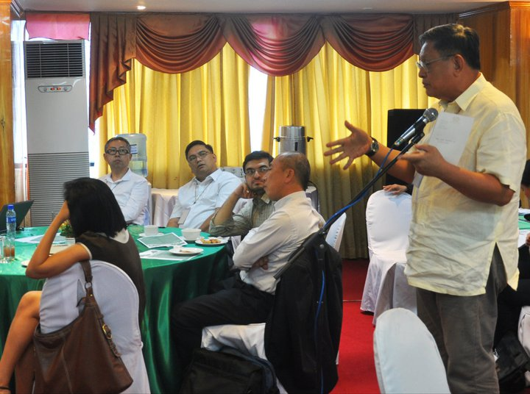

Discussion with the Participants

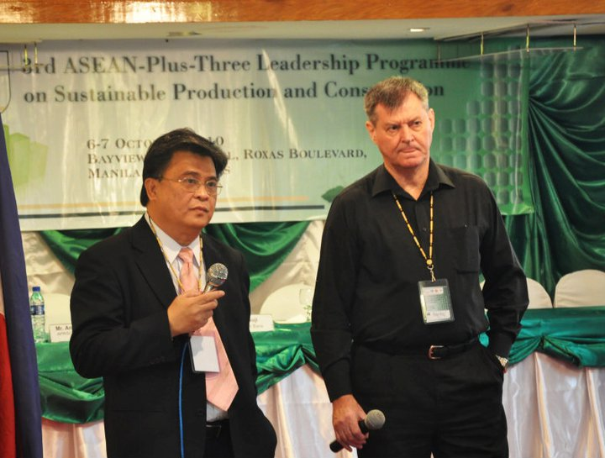

Discussion with the Participants

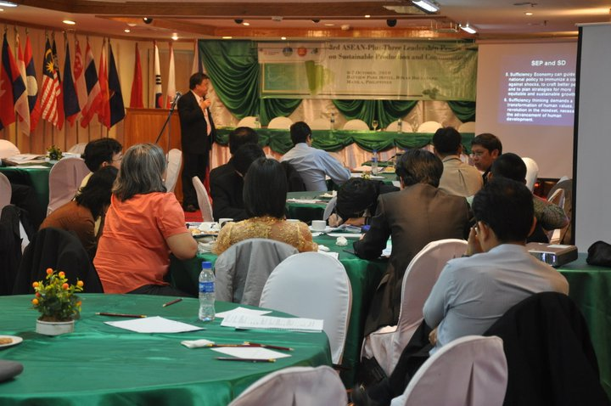

Poverty Reduction: SPC helps reduce poverty and achieve sustainable development; reconciling these issues by Mario Tabucanon for Zinaida Fadeeva of the United Nations University Institute of Advanced Studies

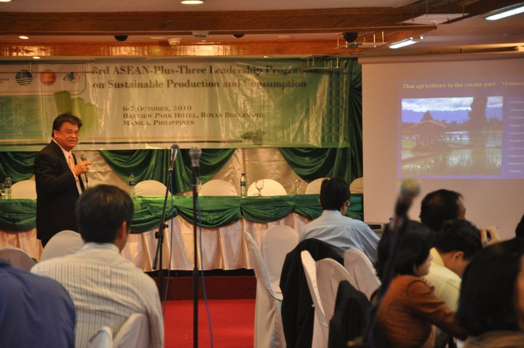

Sufficiency Economy Philosophy: Viewing the philosophy as an approach to SPC – moderation, rationality, resilience, knowledge wisdom, and morality; Thailand experience in agriculture, government and business sectors by Mario Tabucanon
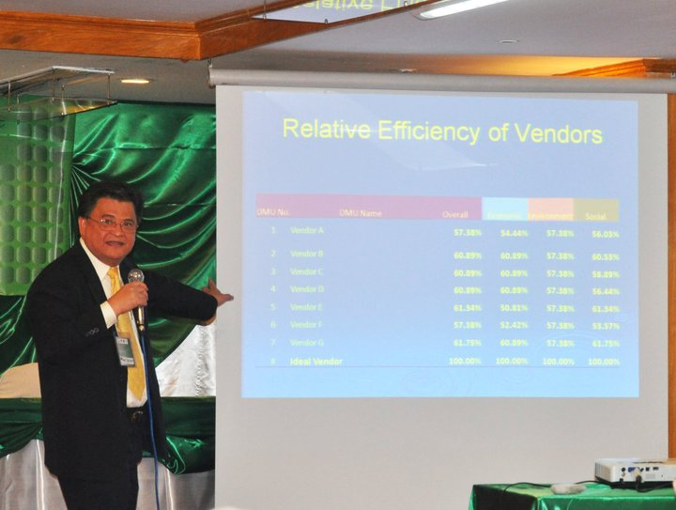

Sustainable Supply Chain and Logistics: Ensuring sustainable production practices of the entire supply chain and logistics; vendor evaluation and selection for sustainability using analytic hierarchy process by Mario Tabucanon

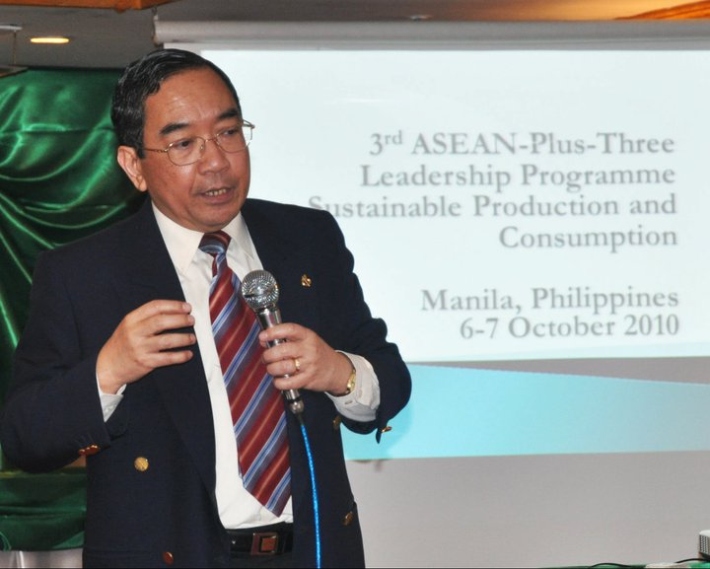

Corporate Social Responsibility in ASEAN: Incorporating the dimensions of sustainability – economic, environmental and social – in business planning and practice; key skills, strategies and tools that businesses and their managers need to adopt successful CSR programs by
Filemon Uriarte, Jr. of the ASEAN Foundation

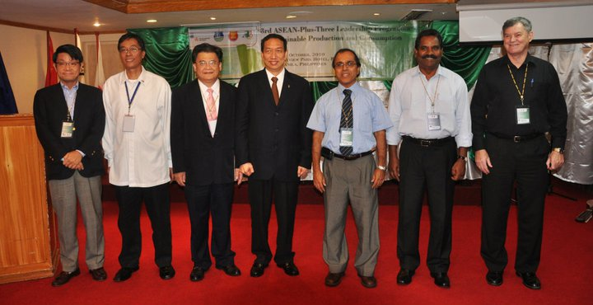

Resource Speakers with PCCI President Ambassador Francis Chua

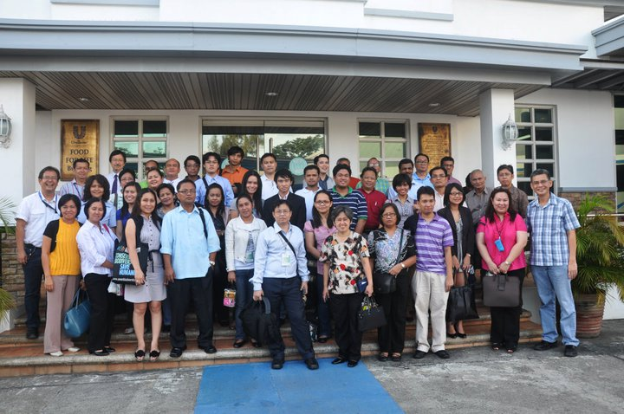

Participants of the 3rd ASEAN-Plus-Three Leadership Programme on Sustainable

Production and Consumption

